**DARPA ZENITH**

**Modeling and Simulation Report**

**Code Version 1.0**

**GE Vernova Advanced Research**

**12th July 2024**

* **GE Vernova Advanced Research**: Dhanushkodi Durai Mariappan, Greg Radighieri, Sudharsan Kalidoss, Dongil Shin, Hullas Sehgal, Bridget McShane, Sreekar Karnati, Juan Pablo Cilia
* **University of Laval**: Simon Thibault, Denis Brousseau

**Table of Contents**

**1.** **Executive Summary of project** 8

**2.** **Codes for Analytical model** 9

2.1. Summary of code deliverables 9

2.2. Details of Code Deliverables 10

2.2.1. Influence function for single coil 10

2.2.2. Helmholtz coils 11

2.2.3. 271 EM coils with Helmholtz coil 12

2.2.4. Influence of coil diameters - 1D 13

2.2.5. Influence of coil diameters - 2D 14

2.2.6. Magnetic field calculation of single tilted coil 15

2.3. Modeling Approach 16

2.4. Example Cases 18

2.4.1. Single Electromagnetic (EM) coil (Weekly update on 1/4/2024) 18

2.4.2. Helmholtz coil (Weekly update on 2/1/2024) 20

2.4.3. Multiple EM coils (271) with Helmholtz coil (Weekly update on 1/11/2024) 22

2.4.4. Influence of coil diameters - 1D (Weekly update on 1/4/2024) 23

2.4.5. Influence of coil diameters - 2D (Weekly update on 1/4/2024) 24

2.4.6. Magnetic field calculation of single tilted coil (Weekly update on 1/11/2024) 25

**3.** **COMSOL Multiphysics model** 26

3.1. Summary of Code Deliverables 26

3.2. Details and Settings of Code Deliverables 26

3.2.1. 2D COMSOL of simulation of the mirror 26

3.2.2. 3D COMSOL simulation 35

3.3. Modeling Approach 38

3.4. Example Cases 50

3.4.1. 2D COMSOL of simulation of the mirror 50

3.5. Simulation Model Validation with Experimental Results 54

**4.** **Codes for system control** 61

4.1. Summary of Code Deliverables 61

4.2. Details of Code Deliverables 61

4.2.1. Single Coil Control 61

4.2.2. 7 Coil MIMO Control 61

4.3. Modeling Approach 62

4.4. Example Cases 64

4.4.1. Simulations 66

4.5. Example Cases 69

4.5.1. FDM model 69

4.5.2. Single Coil Control 69

**5.** **Reference** 70

**6.** **Appendix: Source codes** 71

6.1. Codes for Analytical models 71

6.1.1. Influence function for unit cell – MATLAB 71

6.1.2. Helmholtz coils - MATLAB 73

6.1.3. 271 EM coils with Helmholtz coil - MATLAB 75

6.1.4. Influence of Coil diameters – 1D 79

6.1.5. Influence of Coil diameters – 2D 85

6.1.6. Magnetic field calculation of single tilted coil 90

6.2. COMSOL Multiphysics simulation 93

6.3. Codes for system controller 93

6.3.1. FDM Model - MATLAB 93

6.3.2. Single Coil Control - MATLAB 96

**List of Figures**

Figure 1. Conceptual design of the COSMOS 7

Figure 2. Code structure of Influence function for single coil 9

Figure 3. Code structure of Helmholtz coil 10

Figure 4. Code structure of 271 EM coils with Helmholtz coil 11

Figure 5. Code structure of Influence of coil diameters - 1D 12

Figure 6. Code structure of Influence of coil diameters – 2D 13

Figure 7. Code structure of Magnetic field calculation of single tilted coil 14

Figure 8. Geometry of a “thick” round Helmholtz coil (left) and normalized graphs of magnetic field generated by various “Thick” Helmholtz coils [3] 16

Figure 9. EM Coil design 17

Figure 10. Magnetic Field and Ferrofluid surface deformation results from the MATLAB execution file “infunc_single.m” 18

Figure 11. Geometry of Helmholtz coil (a) Liquid Mirror geometry (b) Helmholtz coil geometry [3] 19

Figure 12. Magnetic field of selected Helmholtz coil design using MATLAB execution file “infunc_Helmholtz.m” 20

Figure 13. Selected EM coil (actuator) array and coil geometry 21

Figure 14. Deformation of mirror surface with 0.1 A of EM coil current and 100 A (idealized) of Helmholtz coil 21

Figure 15. Normalized influence function with various spacing between EM coils 22

Figure 16. RMSE as a function of distance between actuators for a square (left) and hexagonal (right) grid. The distance between the actuators is given in units of the Gaussian standard deviation. The curve colors correspond to the usable fraction of the mirror diameter (50, 57, and 65%) 23

Figure 17. Influence functions from edge and center EM coils 24

Figure 18. 2D Model of single EM coil with porous media and ferrofluid 26

Figure 19. Geometry settings 26

Figure 20. Material selection settings for coil and surrounding structures 27

Figure 21. Material selection settings for porous media 27

Figure 22. Material selection settings for 2-phase flow (ferrofluid and air) 28

Figure 23. Magnetic fields settings for coil 29

Figure 24. Magnetic fields settings for Ampere’s law in fluids 30

Figure 25. Flow settings for Ferrofluid and air 31

Figure 26. Flow settings for Ferrofluid, air, and porous medium 32

Figure 27. Level set settings 1 33

Figure 28. Level set settings 2 33

Figure 29. Schematic of 3D simulation domain 34

Figure 30. Domains selected for solving fluid equations in Laminar flow, Level set and magnetic field modules. 35

Figure 31. Setting direction of the coil current for EM coil. 35

Figure 32. Schematic of full mirror setup with 75 coils. 36

Figure 33. Governing equations for systems and its coupling 37

Figure 34. Flow charts depicting the coupling among three physics (Ferrofluid, Porous media, Magnetic field) and the verification of COMSOL results using an analytical model 38

Figure 35. Schematic of COMSOL simulation setup 39

Figure 36. Interaction of ferrofluid with applied EM field 42

Figure 37. Interaction of ferrofluid with gravity (no EM field) 42

Figure 38. Ferrofluid saturation in porous media 44

Figure 39. Ferrofluid saturation in the porous media over time 45

Figure 40. (a) Magnetic flux distribution of the actuation coil and (b) volume fraction of the ferrofluid 46

Figure 41. Comparison of ferrofluid response 47

Figure 42. Simulation domain of Helmholtz coil, (b) Background magnetic field generated in 3D domain and (c) magnetic field generated in 2D domain 48

Figure 43. Response of ferrofluid on tilt plane 49

Figure 44. COMSOL simulation results – Ferrofluid and EM and Helmholtz coils (no porous media) 50

Figure 45. COMSOL simulation results – Ferrofluid and porous media (no magnetic field applied) 50

Figure 46. COMSOL simulation results – Ferrofluid, porous media, and Magnetic field (2.25 Gauss of magnetic field from Helmholtz coil) 51

Figure 47. COMSOL simulation results – Ferrofluid, porous media, and Magnetic field 22.5 Gauss of magnetic field from Helmholtz coil) 52

Figure 48. Experimental setup to measure the ferrofluid surface profile 53

Figure 49. Measured surface profiles of ferrofluid with and without porous media 53

Figure 50. Measured maximum amplitude of ferrofluid surface with different EM coil currents 54

Figure 51. Comparison of ferrofluid surface profiles between simulation using analytical code and experiments 55

Figure 52. Simulation setup for 2D Multiphysics simulation using COMSOL 56

Figure 53. Mesh convergence tests for 2D COMSOL simulation 57

Figure 54. Comparison between measured ferrofluid surface profiles and simulation results using 2D COMSOL simulation with different EM coil currents (10mm distance between ferrofluid top surface and EM coil) 58

Figure 55. Comparison between measured ferrofluid surface profiles and simulation results using 2D COMSOL simulation with EM coil currents of 0.5 A (11mm distance between ferrofluid top surface and EM coil) 59

Figure 56. unit cell consisting of a ferrofluid film with an EM coil actuator. This configuration was used for characterizing the system model, where the transfer function between the z-axis fluid section height (shown as orange circle) due to an EM coil placed right below it, was obtained. 61

Figure 57. MIMO model configuration with arrays of EM coil actuators influencing the displacement at the fluid surface. The transfer function between the z-axis fluid section height (shown as orange circle) due to all the EM coils, was obtained. 62

Figure 58. 7-unit cell configuration of 7-EM coils arranged in a hexagonal geometry 63

Figure 59. shows a block diagram configuration of open loop and closed loop. 64

Figure 60. shows the block diagram configuration of the closed loop MIMO control with the decoupled control. 64

Figure 61. shows the block diagram configuration of the closed loop MIMO control with the decoupled control and disturbance rejection. 65

Figure 62. Bode plots of open loop (OL) and closed loop (CL) transfer function 66

Figure 63. Simulation result showing comparison between LM system response to a ramp input disturbance injection with and without the controller. 66

Figure 64. Simulation result showing comparison between LM system response to a ramp input disturbance injection with and without the controller 67

Figure 65. Step response of single coil: comparison between model from Azhar Iqbal and Denis Brousseau 68

Figure 66. Open loop and Closed loop response of single coil to step input 69

**List of Tables**

Table 1. List of code deliverables-Analytical model 8

Table 2. Design parameters of EM coil 17

Table 3. Selected design parameters of Helmholtz coil 19

Table 4. List of code deliverables-COMSOL 25

Table 5. Ferrofluid (EFH1) properties 41

Table 6. Design parameters of Helmholtz coil 47

Table 7. List of code deliverables-System control 60

**Revision History**

Version 0.0 -------------------------------------------------------------------------------------- 4/5/2024

Version 1.0 -------------------------------------------------------------------------------------- 7/12/2024

# **Executive Summary of project**

GE Research (GE), in collaboration with the Université Laval (UL) and Raytheon Technologies Research Center (RTRC), proposes to develop a Capillary-Operated Space Mesoporous Optical System (COSMOS), as summarized in Figure 1. This approach will leverage the economic benefits of liquid mirrors while addressing one of its fundamental limitations—its inability to tilt.



Figure 1. Conceptual design of the COSMOS

The project aims to form a non-rotating liquid mirror in a novel mesoporous structure containing ferrofluid and a thin, metallic liquid film by combining capillary forces and electromagnetic fields. The mesoporous structure enables capillary forces to form the parabolic-free surface of the film, and any undulations in the free surface will be corrected using electromagnetic forces provided by the magnet array. COSMOS provides multiple advantages, including less electromagnetic actuation force, heat dissipation, and overall system mass. Furthermore, by confining the ferrofluid to the porous structure, COSMOS system can circumvent the Rosensweig instability, a well-known phenomenon associated with ferrofluid based mirrors.

# **Codes for Analytical model**

## Summary of code deliverables

|  |  |  |  |
| --- | --- | --- | --- |
| **NO** | **Code title** | **Code outcomes** | **Software** |
| 1 | Influence function for unit cell | Coil preliminary design | MATLAB |
| 2 | Helmholtz coils | Compare Helmholtz coil magnetic field with EM coil magnetic field to make sure 10X with Helmholtz coil | MATLAB |
| 3 | Multiple EM coils (271)  with Helmholtz coil | Verify 3D COMSOL simulation results and total power output calculations | MATLAB |
| 4 | Influence of coil diameters - 1D | Optimal RMSE response over partial area of the mirror for a given actuator diameter | Python |
| 5 | Influence of coil diameters - 2D | Optimal RMSE response over partial area of the mirror for a given actuator diameter | Python |
| 6 | Magnetic field calculation of single tilted coil | Ferrofluid deformation with a tilted surface | Python |

Table 1. List of code deliverables-Analytical model

## 

## Details of Code Deliverables

### Influence function for single coil

* **Execution file**: infunc_single.m
* **Folder name that contains the execution file**: ‘Analytical_Models’ – ‘Matlab code for release’ – ‘InfluenceFunction_SingleCoil’
* **Description**: Generate the influence function and ferrofluid deformation based on single coil design and input conditions
* **Input data to codes**: x and y coordinates, EM coil geometry (radius and height), Current input to EM coil, Ferrofluid offset distance from EM coil
* **Outputs from codes**: Influence function, Ferrofluid deformation
* **Code structure**

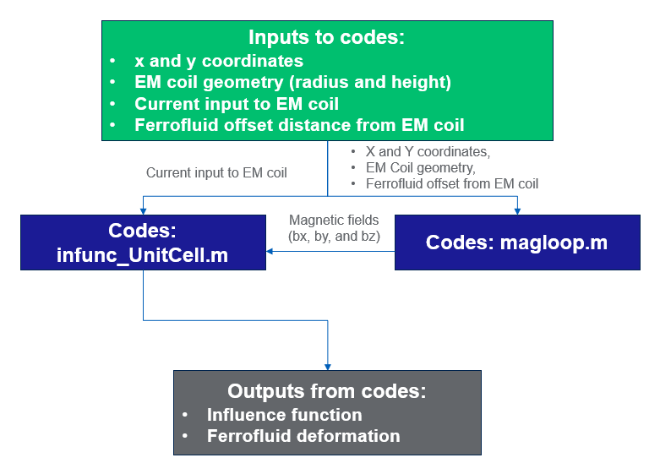

Figure 2. Code structure of Influence function for single coil

### Helmholtz coils

* **Execution file**: infunc_Helmholtz.m
* **Folder name that contains the execution file**: ‘Analytical_Models’ – ‘Matlab code for release’ – ‘HelmholtzCoil’
* **Description**: Generate the influence function based on Helmholtz coil design and input conditions
* **Inputs**: x and y coordinates, EM coil geometry (radius and height), Current input to Helmholtz coil
* **Outputs from codes**: Influence function
* **Code structure**

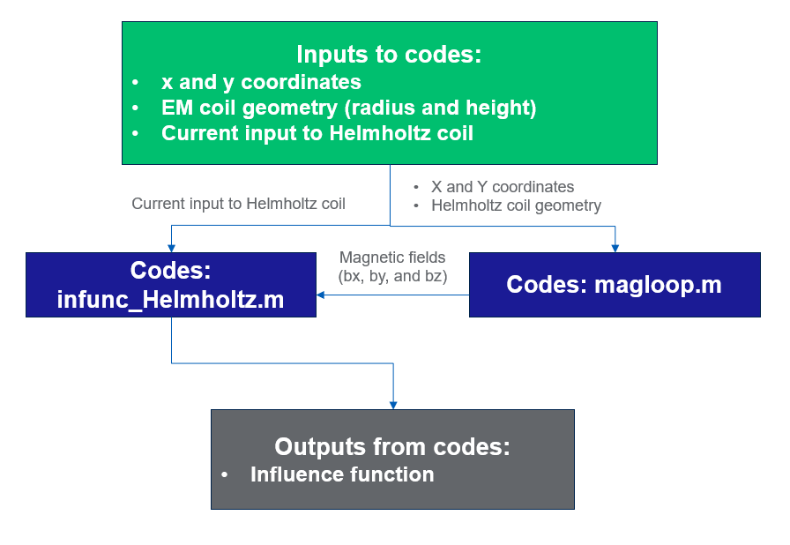

Figure 3. Code structure of Helmholtz coil

### 271 EM coils with Helmholtz coil

* **Execution file**: infunc.m
* **Folder name that contains the execution file**: ‘Analytical_Models’ – ‘Matlab code for release’ – ‘EMCoil271_HelmholtzCoil’
* **Description**: Generate the influence function based on full array of EM and Helmholtz coils design and input conditions
* **Inputs**: x and y coordinates of each EM coil center, EM and Helmholtz coil geometry, Current inputs to EM and Helmholtz coils, Ferrofluid offset distance from EM coil
* **Outputs from codes**: Influence function, Ferrofluid deformation
* **Code structure**

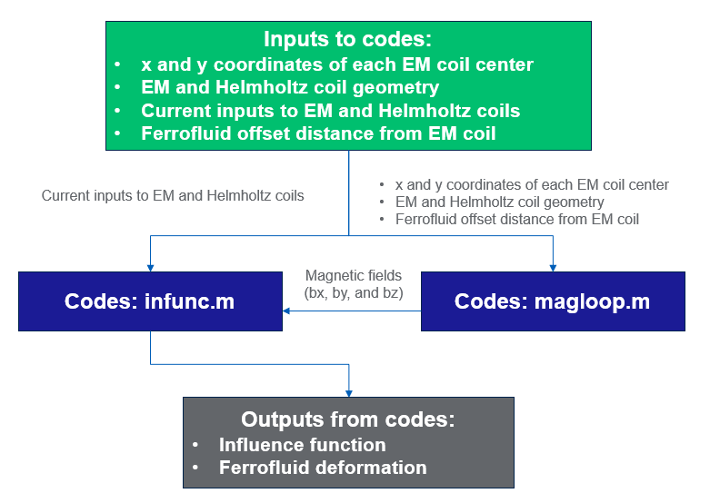

Figure 4. Code structure of 271 EM coils with Helmholtz coil

### Influence of coil diameters - 1D

* **Execution file**: geometry1d_investigation_v4.py
* **Folder name that contains the execution file**: ‘Analytical_Models’ – ‘Python code for release’
* **Description**: Analyze 1d array of actuators approximated with gaussian function of influence and the spacing between them using normalized units
* **Inputs**: Normalized minimal actuator diameter, Normalized maximum actuator diameter, Number of actuator
* **Outputs from codes**: Optimal RMSE response over partial area of the mirror for a given actuator diameter
* **Code structure**

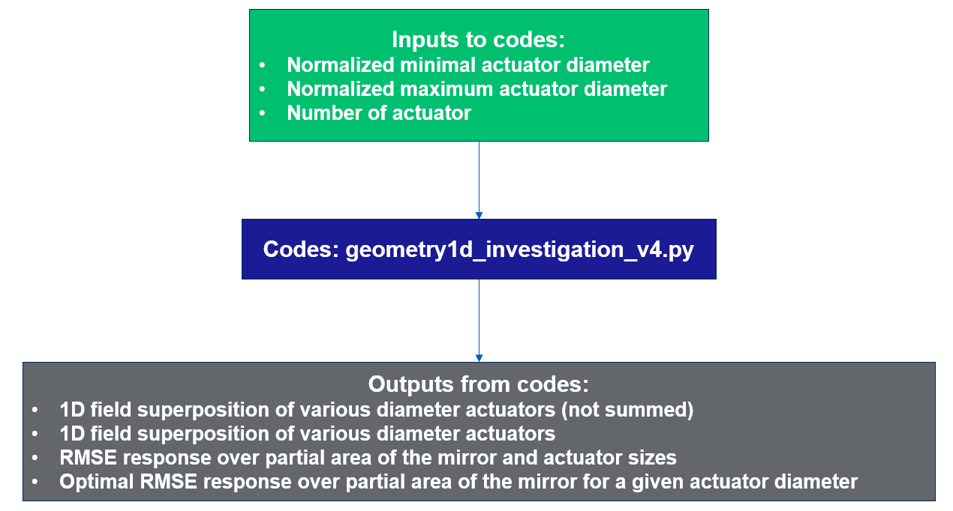

Figure 5. Code structure of Influence of coil diameters - 1D

### Influence of coil diameters - 2D

* **Execution file**: geometry2d_investigation_v2.py
* **Folder name that contains the execution file**: ‘Analytical_Models’ – ‘Python code for release’
* **Description**: Analyze 2d array of actuators approximated with gaussian function of influence and the spacing between them for normalized dimensions
* **Inputs**: Normalized minimal actuator diameter, Normalized maximum actuator diameter, Number of actuator in every dimension
* **Outputs from codes**: 2D field superposition of various diameter actuators, RMSE response over full mirror and actuator size, RMSE response over partial area of the mirror for a various actuator diameter
* **Code structure**

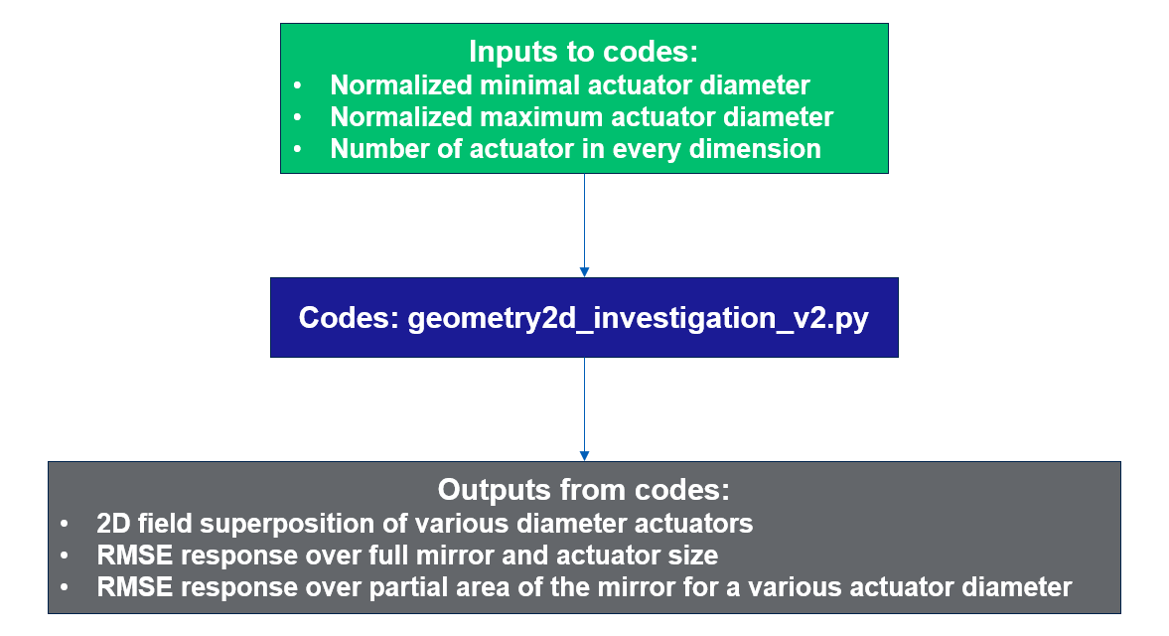

Figure 6. Code structure of Influence of coil diameters – 2D

### Magnetic field calculation of single tilted coil

* **Execution file**: magnetic_field.py
* **Folder name that contains the execution file**: ‘Analytical_Models’ – ‘Python code for release’
* **Description**: Analyze the impact of tilt on the actuator magnetic influence function
* **Inputs**: Dimension to investigate the field for radial coordinate, Relative Permeability constant, Ferrofluid density, Current in the coil, Coil radius
* **Outputs from codes**: Comparison of the expected ferrofluid surface deviation of a single coil for a flat surface and a tilted surface
* **Code structure**

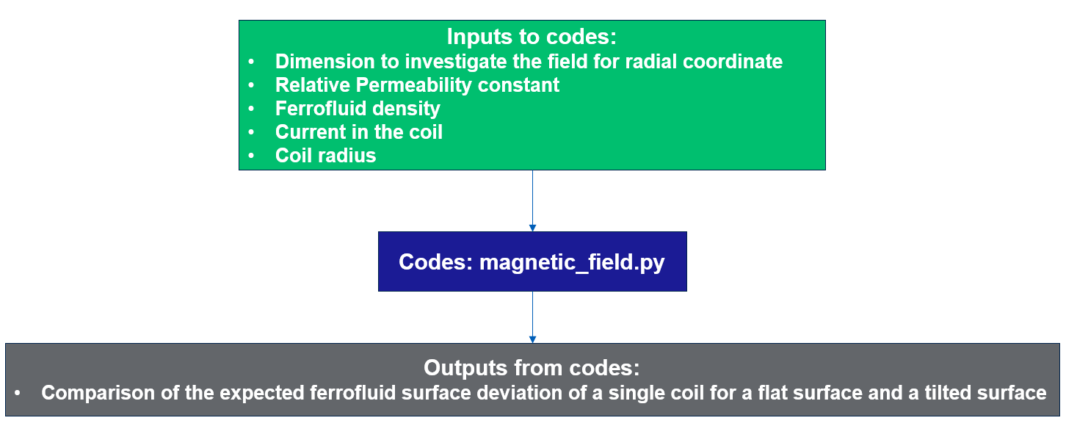

Figure 7. Code structure of Magnetic field calculation of single tilted coil

## Modeling Approach

The analytical formula that describes the surface deformation of ferrofluid in the $x$ and $y$ plan in the presence of a magnetic fields $B$ in $x, y, and z direction$ are given by [1]:

$$h=\frac{\left(μ_{r}-1\right)}{2μ_{r}μ_{0}ρg}({\left|B•n\right|}^{2}+μ_{r}{\left|B⨯n\right|}^{2})$$

where $h$ denotes the ferrofluid deformation, and $μ_{r}$ indicates the relative permeability of ferrofluid, $ρ$ represents the density of ferrofluid while $n$ is a unit vector normal to the surface of the ferrofluid.

The magnetic field $B$ of single coil in perpendicular direction ($z$) to surface can be calculated from the equation in [2], which takes the form of Elliptic integral as:

$$B_{z}=B_{0}\frac{1}{π\sqrt{Q}}(E\left(k\right)\frac{1-α^{2}-β^{2}}{Q-4α}+K(k))$$

where $B_{0}=\frac{μ_{0}I}{2a}$, $α=\frac{r}{a}$, $β=\frac{z}{a}$, $γ=\frac{z}{r}$, $Q=[{\left(1+α\right)}^{2}+β^{2}]$, $k=\sqrt{\frac{4α}{Q}}$, $r=\sqrt{x^{2}+y^{2}}$, $μ_{0}$ is permeability of air, $I$ denotes the current. $E\left(k\right)$ and $K\left(k\right)$ are the first and second orders elliptic integration, respectively. $B_{x}$ and $B_{y}$ can be obtained similarly.

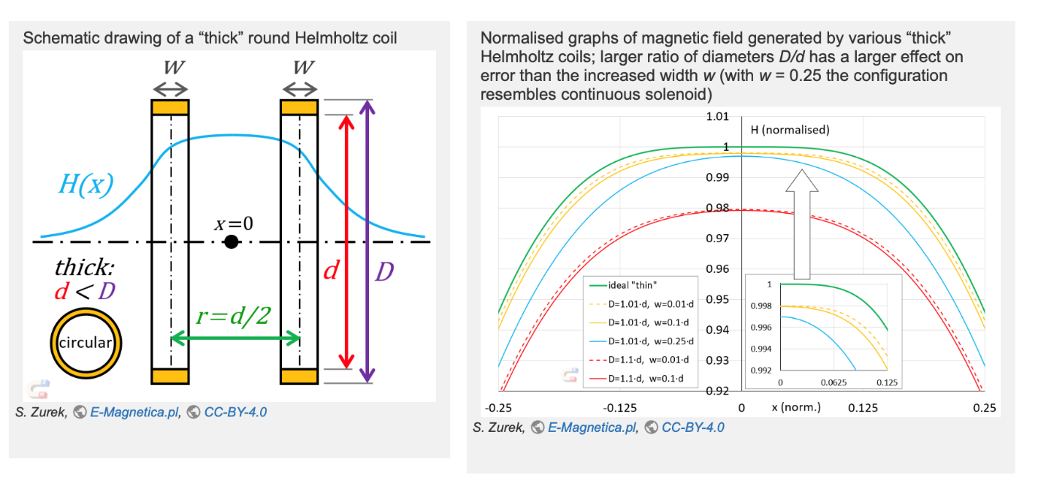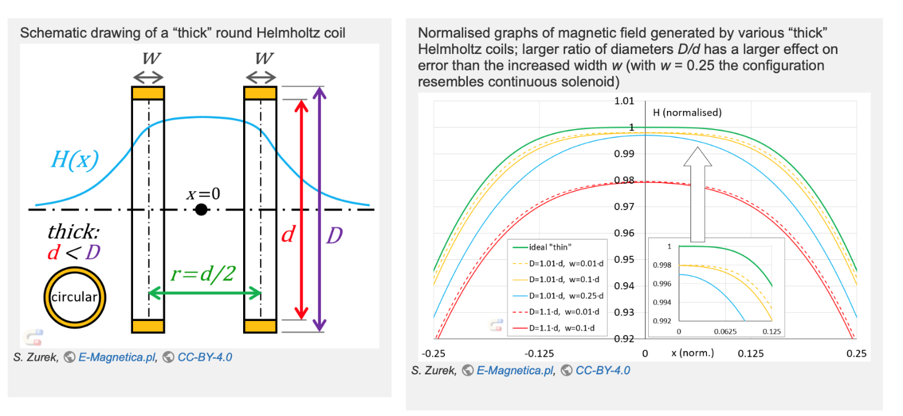

Figure 8. Geometry of a “thick” round Helmholtz coil (left) and normalized graphs of magnetic field generated by various “Thick” Helmholtz coils [3]

The geometry of a real coil is characterized by a finite width w and a finite thickness, the latter of which is determined by the difference between the outer diameter ($D$) and the inner diameter ($d$), as illustrated in Figure 01. As the ratios $D/d$ and $D/d$ decrease, the geometry of the coil more closely approximates that of an ideal 'thin' coil, as depicted in the right panel of Figure 8. In pursuit of an approximation to the ideal coil geometry, the current work selects a design that minimizes the $D/d$ and $D/d$ ratios.

## Example Cases

### Single Electromagnetic (EM) coil (Weekly update on 1/4/2024)

|  |  |
| --- | --- |
| **Design parameters** | **Selected values** |
| Coil current | 0.1 A |
| EM Coil diameter | 35 mm (core diameter 7.8 mm) |
| EM Coil height | 22 mm |
| EM Coil length | 32 m. |
| Number of winding turns | 476 (17 ringsx28 layers) |
| Wire gauge | 20 |
| Wire material | Copper |

Table 2. Design parameters of EM coil

The specific parameters for the selected EM coil are detailed in the Table 2. A coil current of 0.1 A is applied. The diameters of the coil and core are 35 mm and 7.8 mm, respectively. The height and length of the coil have been set at 22 mm and 32 mm, respectively.

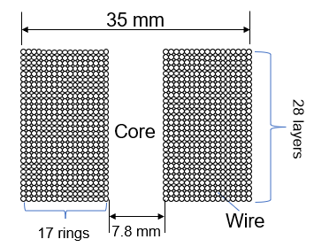

Figure 9. EM Coil design

As illustrated in Figure 9, the coil consists of a total of 476 windings, arranged into 17 rings in the diametral direction and 28 layers in the vertical direction of the coil. A wire with a gauge of 20 and specified material has been selected for this configuration.



Figure 10. Magnetic Field and Ferrofluid surface deformation results from the MATLAB execution file “infunc_single.m”

Utilizing the geometry and design parameters outlined previously, the magnetic field and ferrofluid deformation were computed using a MATLAB script named 'infunc_single.m.' The outcomes of this computation are depicted in Figure 10. On the x-axis, the coordinate represents the distance of the ferrofluid surface from the center of the coil, while the y-axis illustrates the induced amplitude of the ferrofluid surface as a result of the applied current. These results show that the maximum magnetic field and surface amplitude are observed at the coil's center, amounting to approximately 0.37 Gauss and 6 microns, respectively.

### Helmholtz coil (Weekly update on 2/1/2024)

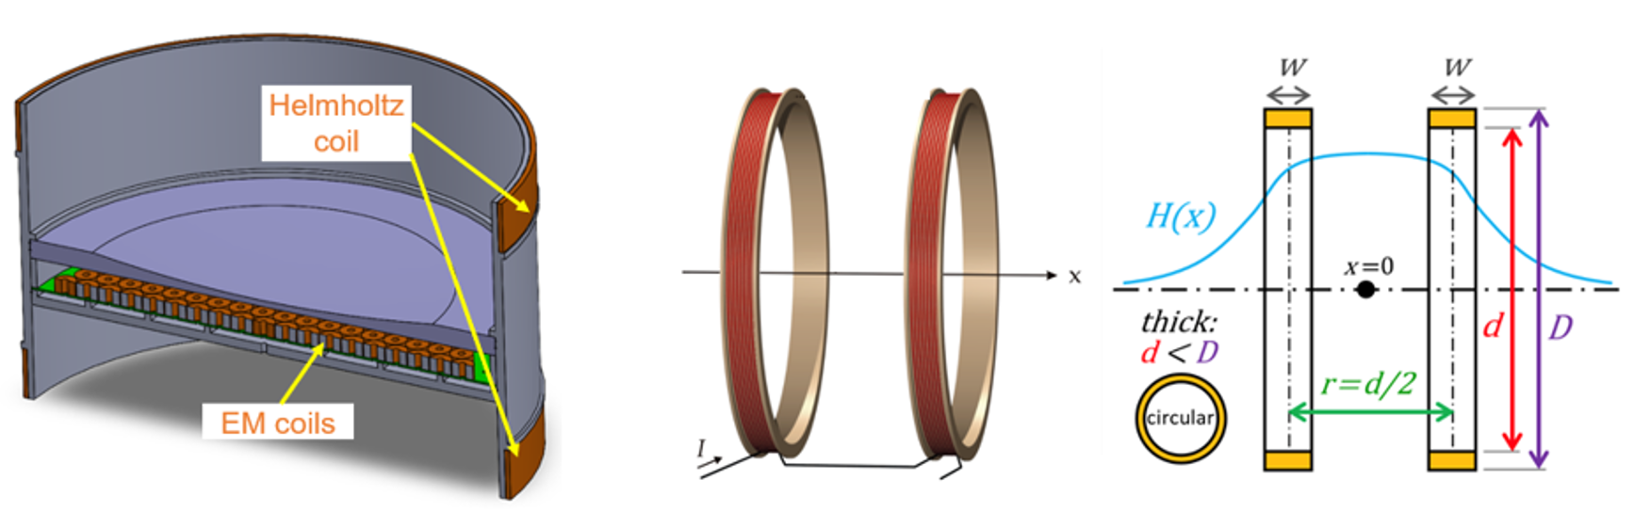

(a)

(b)

Figure 11. Geometry of Helmholtz coil (a) Liquid Mirror geometry (b) Helmholtz coil geometry [3]

The geometry of the Helmholtz coil is depicted in Figure 11. The EM coil arrays are arranged within the circular region of the system, with a pair of Helmholtz coils positioned on the upper and lower sides of the EM coil arrays. The diameter of each Helmholtz coil is 800 mm, and the distance between the two coils is set at 400 mm. Detailed design parameters for the Helmholtz coil are provided in Table 3. The coil's current input is 0.625 A. The wire has a diameter of 2 mm and a length of 400 m, with 160 turns used in the coil's construction. A 12-gauge copper wire is used for the design.

|  |  |
| --- | --- |
| **Design parameters** | **Selected values** |
| **Number of coil** | 2 |
| **Coil current** | 0.625 A |
| **Resistance of wire** | 2.1 Ohm |
| **Wire diameter** | 2 mm |
| **Wire length** | 400 m |
| **Number of wire turns** | 160 |
| **Wire gauge** | 12 |
| **Wire material** | Copper wire |

Table 3. Selected design parameters of Helmholtz coil

To closely align our design with the ideal scenario, we have chosen the dimensions for coil thickness and coil width, based on a Helmholtz coil diameter of 800 millimeters. A 12-gauge copper wire and 106 wire turns were selected, totaling a wire length of 400 meters.



Figure 12. Magnetic field of selected Helmholtz coil design using MATLAB execution file “infunc_Helmholtz.m”

Figure 12 presents the calculated magnetic field resulting from the Helmholtz coil design, as determined by the MATLAB script 'infunc_Helmholtz.m.'. This figure shows that the maximum magnetic field is centered between the two coils, reaching an approximate peak of 2.25 Gauss.

### Multiple EM coils (271) with Helmholtz coil (Weekly update on 1/11/2024)

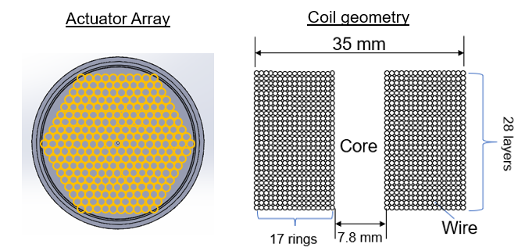

Figure 13. Selected EM coil (actuator) array and coil geometry

Figure 13 presents the chosen layout for the electromagnetic (EM) coil array, which is arranged in a hexagonal pattern, alongside the precise geometry of the EM coils. The actuator array comprises a total of 271 EM coils. The specifics of the EM coil design are detailed in Table 2. The Helmholtz coil design used in the previous section is used along with 271 EM coils.



Figure 14. Deformation of mirror surface with 0.1 A of EM coil current and 100 A (idealized) of Helmholtz coil

Figure 14 depicts the deformation of a liquid mirror surface influenced by 271 EM coils and a Helmholtz coil. The currents supplied to the 271 coils are detailed alongside the MATLAB file provided. An idealized current input of 100 A is applied to the Helmholtz coil. The deformation illustrated in Figure 14 reveals that the ferrofluid surface adopts a parabolic shape, with the maximum deformation of 1.223 μm occurring at the center of the mirror region.

### Influence of coil diameters - 1D (Weekly update on 1/4/2024)

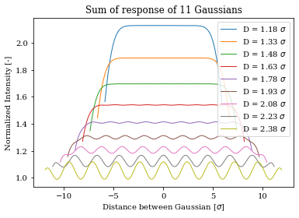

Figure 15. Normalized influence function with various spacing between EM coils

The Python script 'geometry1d_investigation_v4.py' is designed to optimize the spacing, size, and number of actuators to minimize the Root Mean Square Error (RMSE) for a planar distribution of a liquid surface. Figure 15 displays the normalized influence function for varying spacings between EM coils, as derived from the Python code. The findings indicate that optimal spacing is achieved when $D=1.6σ$, which enhances the uniformity of the surface's distribution and its overall size.

### Influence of coil diameters - 2D (Weekly update on 1/4/2024)

|  |  |
| --- | --- |
|  |  |
|  | |

Figure 16. RMSE as a function of distance between actuators for a square (left) and hexagonal (right) grid. The distance between the actuators is given in units of the Gaussian standard deviation. The curve colors correspond to the usable fraction of the mirror diameter (50, 57, and 65%)

The Python script 'geometry2d_investigation_v4.py' is designed to determine the actuator parameters to achieve a target residual RMSE of l/6. The main purpose of the code is to find the spacing, size, geometry, and number of actuators to minimize the RMSE of a planar distribution. Two approximations were made for the simulation:

* The response of the actuators is a pure Gaussian profile (like the actual response found in the literature)
* An actuator is about as large as its FWHM (minimal spacing of 1.177s)

The RMSE and its evolution were analyzed for a 13 x 13 actuator grid in square and hexagonal geometry. Figure 16 shows the RMSE as a function of distance between the actuators for both grid geometries. The RMSE for a square geometry is shown at left while the RMSE for a hexagonal geometry is shown at right on the figure. The results show that the hexagonal geometry enables the best mirror coverage, and that to obtain the best RMSE, we need to increase the number of actuators lying outside the usable mirror diameter. The above simulations were made for a 13 x 13 actuators array and from these results we settled on selecting the credible number of actuators to be a 19 x 19 array which was found to provide the target RMSE over a usable 75% of the actuator array overall diameter.

### Magnetic field calculation of single tilted coil (Weekly update on 1/11/2024)

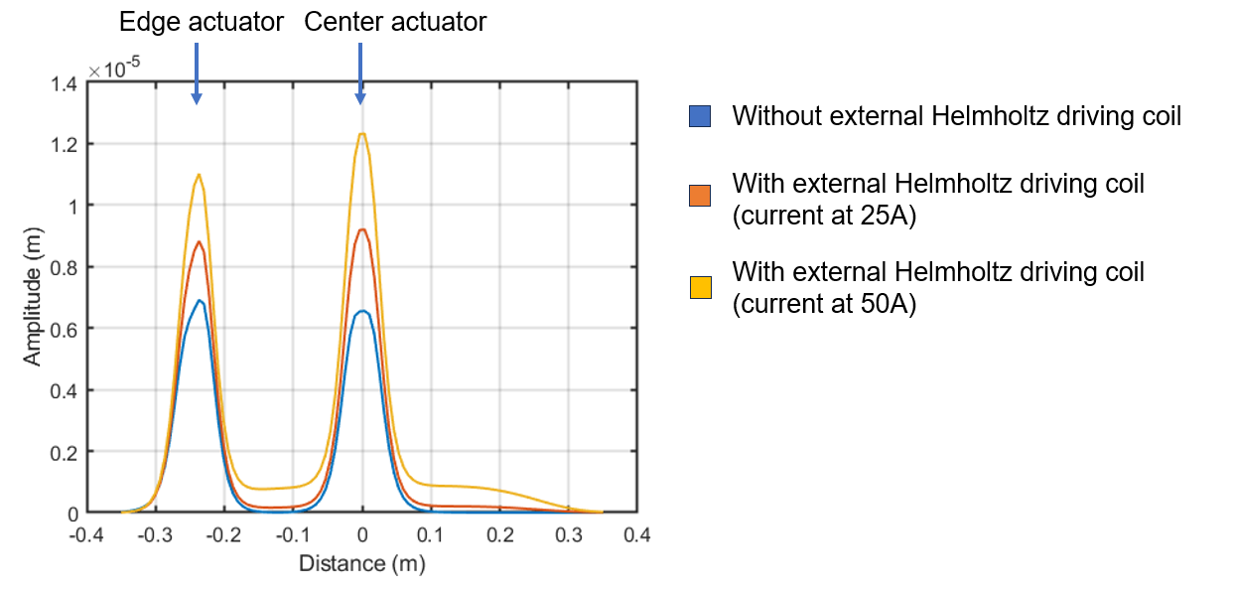

Figure 17. Influence functions from edge and center EM coils

The Python script 'magnetic_field.py' is designed to assess how tilt affects the magnetic influence function of actuators. Figure 17 illustrates the influence functions for coils positioned at both the edge and the center of the mirror surface, where an artificial slope has been introduced to mimic the effect of surface tilt. The analysis reveals a slight skewness in the edge influence functions, attributed to the tilting of the parabolic liquid surface. Furthermore, it is observed that the amplitude of this skewness increases with a higher current input to the Helmholtz coil. In the absence of the external Helmholtz coil, the influence functions exhibit negligible skewness, in contrast to the scenarios where the coil is active.

# **COMSOL Multiphysics model**

## Summary of Code Deliverables

|  |  |  |  |
| --- | --- | --- | --- |
| **NO** | **Code title** | **Code outcomes** | **Software** |
| 1 | 2D COMSOL of simulation of the mirror | 2D simulation results of ferrofluid interacting with porous media and EM & Helmholtz coils | COMSOL |

Table 4. List of code deliverables-COMSOL

## Details and Settings of Code Deliverables

### 2D COMSOL of simulation of the mirror

* **Execution file**:
  + **Case file with Ferrofluid and porous media :** Unit_cell_one_coil_ls_no_em_pm.mph
  + **Case file with Ferrofluid and magnetic field:**

Unit_cell_one_coil_ls_no_pm_em.mph

* + **Case file with Ferrofluid, magnetic filed, and porous media:**

Unit_cell_one_coil_ls_with_em_pm_g_field.mph

* **Folder name that contains the execution file**: ‘COMSOL Multiphysics_Models’
* **Description**: Perform Multiphysics simulation of single coil system considering magnetic fields from EM and Helmholtz coils, ferrofluid, and porous media
* **Inputs**: EM and Helmholtz coil geometry, ferrofluid properties, current inputs to coils
* **Outputs from codes**: Influence function

The Figure 18-Figure 28 show the simulation settings used for COMSOL Multiphysics simulation results.

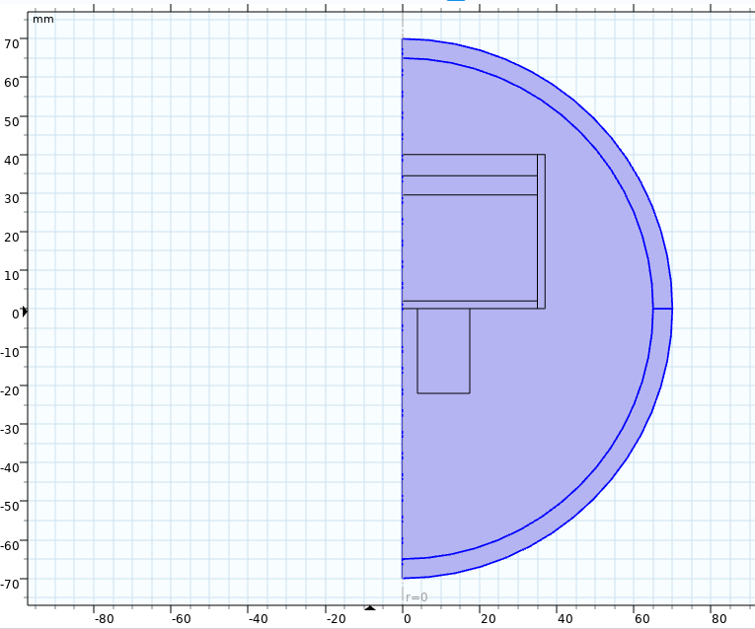

Air

EM Coil

Ferrofluid (reservoir)

Porous media

**Symmetry axis**

Figure 18. 2D Model of single EM coil with porous media and ferrofluid

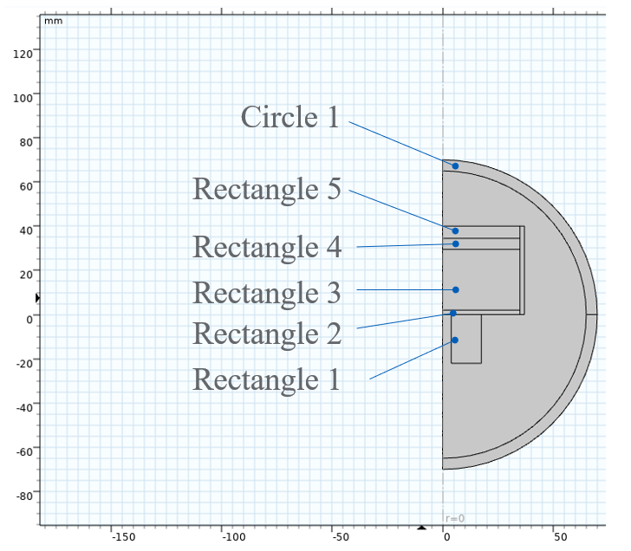

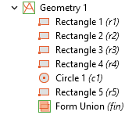

Figure 19. Geometry settings

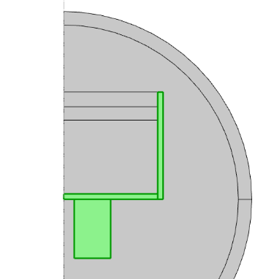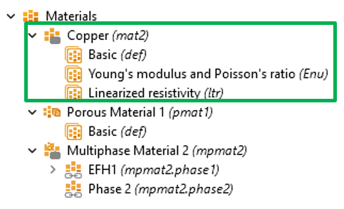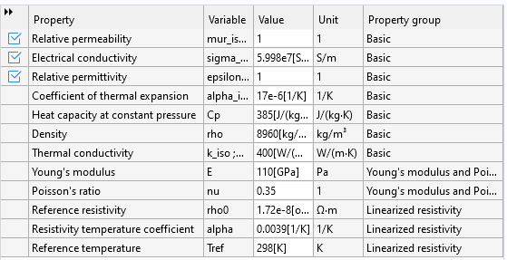

Figure 20. Material selection settings for coil and surrounding structures

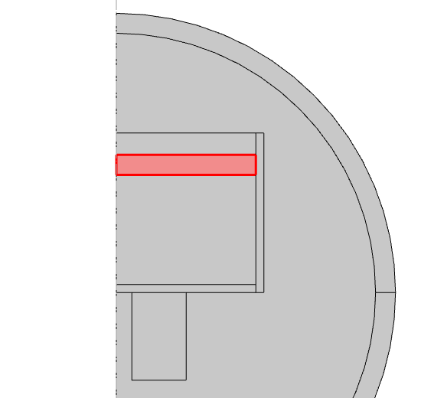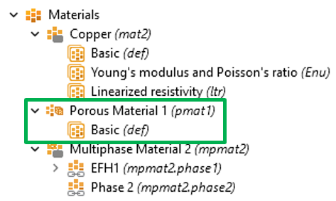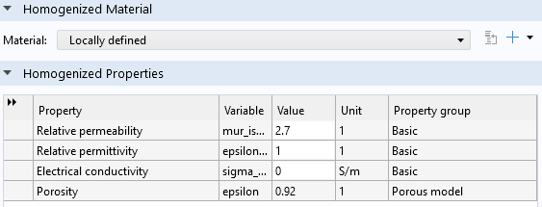

Figure 21. Material selection settings for porous media

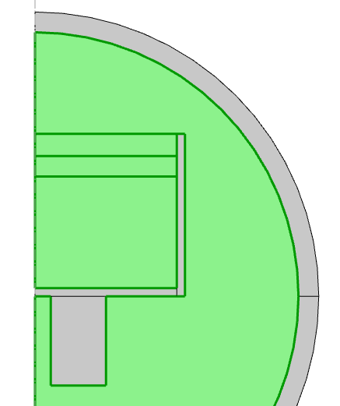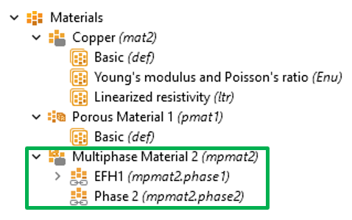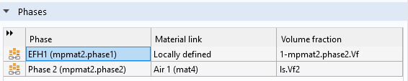

Figure 22. Material selection settings for 2-phase flow (ferrofluid and air)

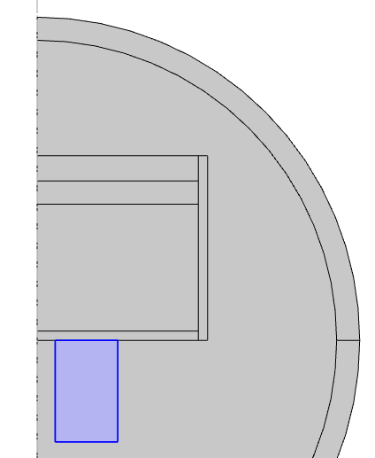

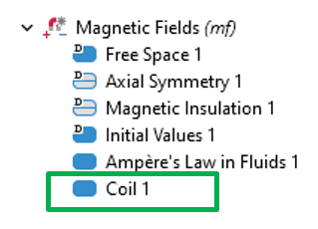

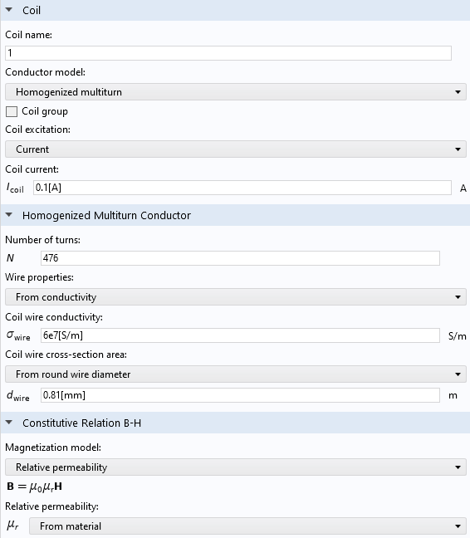

Figure 23. Magnetic fields settings for coil

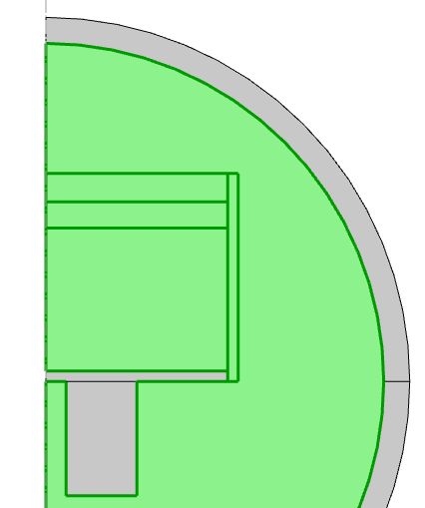

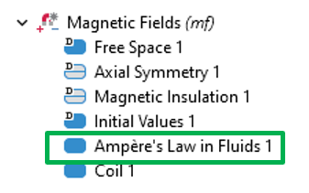

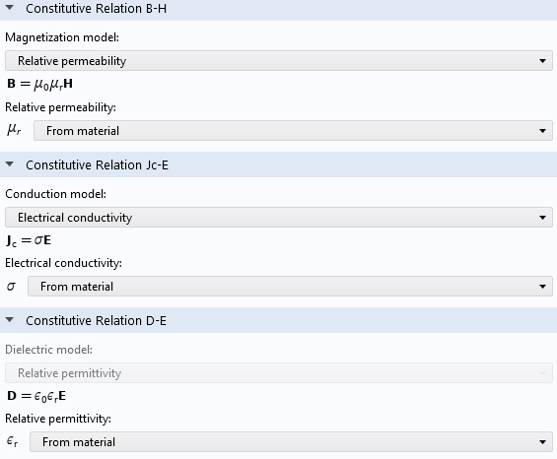

Figure 24. Magnetic fields settings for Ampere’s law in fluids

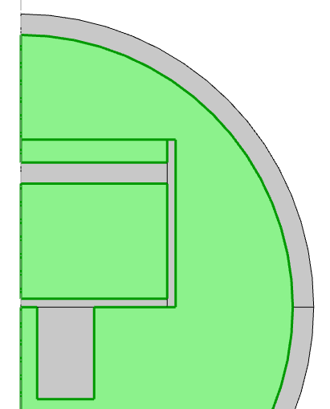

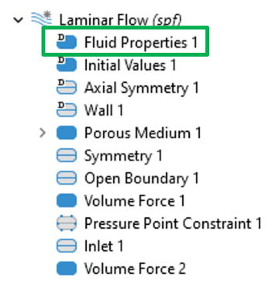

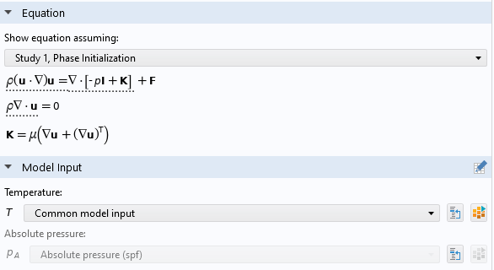

Figure 25. Flow settings for Ferrofluid and air

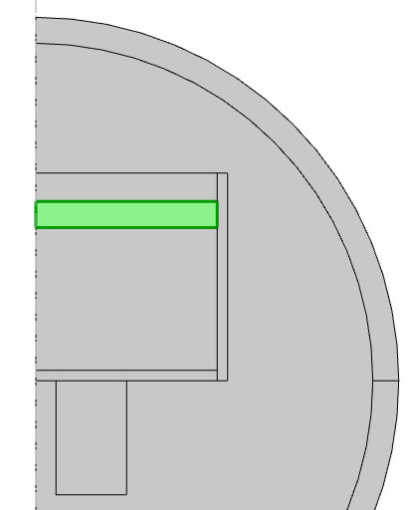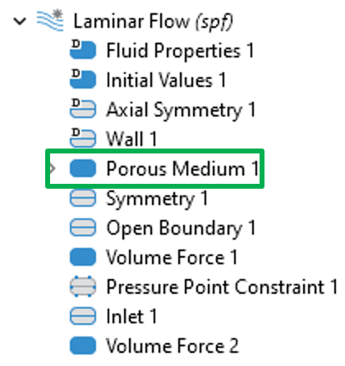

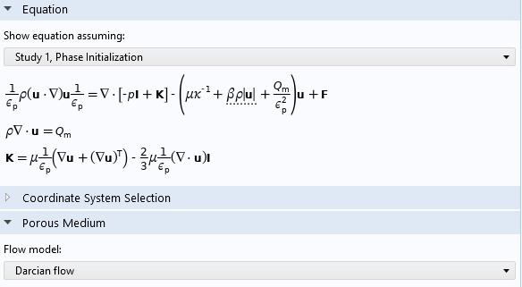

Figure 26. Flow settings for Ferrofluid, air, and porous medium

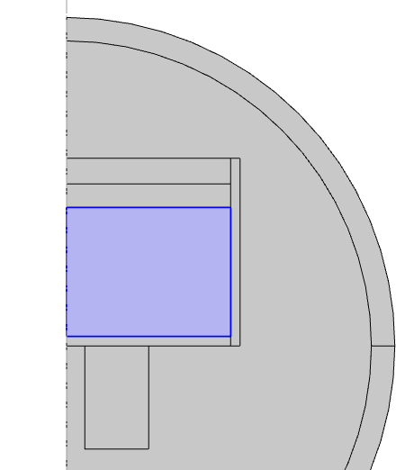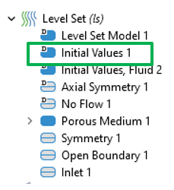

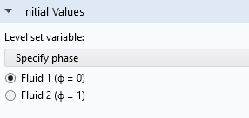

Figure 27. Level set settings 1

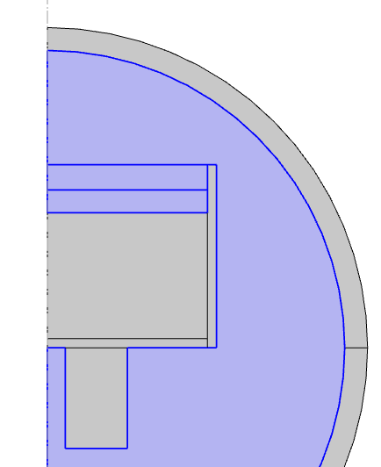

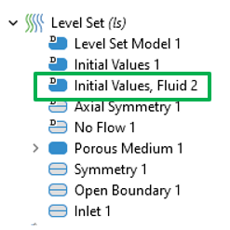

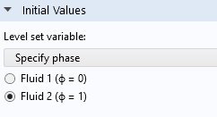

Figure 28. Level set settings 2

### 3D COMSOL simulation

The 3D simulation setup is made similar to the 2D setup. The 3D simulation is symmetric about both x and y- axes. Therefore, one quadrant of the domain is modeled. The schematic of the 3D simulation domain is shown in Figure 29.

|  |
| --- |
| Figure 29. Schematic of 3D simulation domain |

The material, magnetic, fluid and porous media properties of the simulation are defined similar to the 2D simulation setup. In order to reduce the simulation wall time, the fluid equations are not solved in all the domains. Figure 30 shows the domain where the fluid equations are solved. In magnetic field module, the Ampere’s law in fluid section, only the domains where fluid equations are solved is selected. Since one-fourth of the coil is modeled for simulation, the coil length multiplication factor is increased to 4. In addition to the electro-magnetic coil properties, the 3D coil requires direction of the current flow (Figure 31).

|  |
| --- |
| Figure 30. Domains selected for solving fluid equations in Laminar flow, Level set and magnetic field modules. |

|  |
| --- |
| Figure 31. Setting direction of the coil current for EM coil. |

The liquid mirror system consists of 271 EM coils. One-quadrant of the system consists of 75 coils. Similar to the settings described above, the 3D simulation setup is configured for 75 coil setup as shown in *Figure 32*. The center coil has a coil length multiplication of 4 and coils at the symmetric plane has 2 (only one half of the coils is modeled).

|  |
| --- |
| Figure 32. Schematic of full mirror setup with 75 coils. |

## Modeling Approach

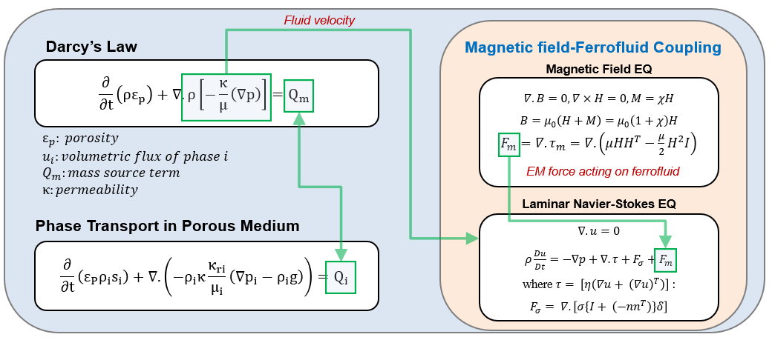

Figure 33. Governing equations for systems and its coupling

To validate the preliminary design results obtained from analytical models, a COMSOL Multiphysics simulation is performed. This simulation accounts for all three components of the physical system: ferrofluid, porous media, and the magnetic field generated by a coil, utilizing the Finite Element Method. In contrast to the analytical model, which doesn’t consider porous media, the COMSOL simulation provides a more accurate prediction of the system's response by incorporating the physics of porous media. The analytical model will be used to design the control system for closed loop operation, to better regulate and track the desired FDM wavefront geometry. The closed loop performance will be validated in COMSOL simulations. Figure 33 illustrates the governing equations used in the COMSOL simulations and their interconnections. The flow dynamics of the ferrofluid are calculated based on the Laminar Navier-Stokes (N-S) equation. The deformed shape of the ferrofluid is simulated by coupling the Laminar N-S equation with the Magnetic Field equation, as shown in the figure. To integrate the two systems, the electromagnetic (EM) force, $F_{m}$, derived from the Magnetic Field equation, is introduced as a forcing term in the N-S equation. To model the porous media above the ferrofluid, Darcy's Law is applied in conjunction with the phase transport equation, as the fluid flow represents a two-phase flow consisting of air and ferrofluid. Darcy’s Law is coupled with the phase transport equation by setting the mass source term, $Q_{m}$, in Darcy’s Law equal to the sum of the mass source terms, $Q_{i}$, for each individual volume fraction. Then, the porous media system, which comprises Darcy's Law and the phase transport equation, is coupled with the magnetic field-ferrofluid system. This is achieved by using the flow velocity, calculated from the porous media system, as an input to the magnetic field-ferrofluid system, as demonstrated in the figure.

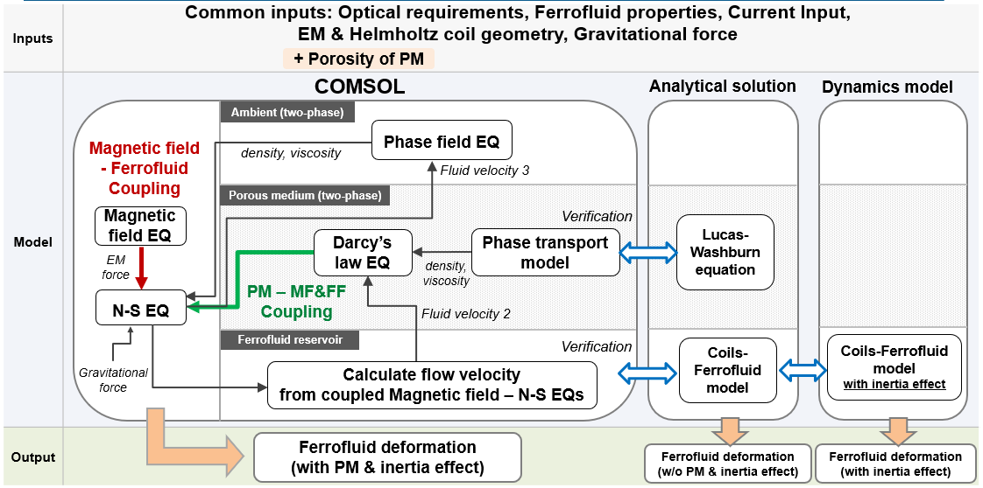

Figure 34. Flow charts depicting the coupling among three physics (Ferrofluid, Porous media, Magnetic field) and the verification of COMSOL results using an analytical model

Figure 34 presents an overview of the modeling approaches to be utilized for system modeling. We employ three distinct modeling approaches: COMSOL simulation, analytical solution, and dynamics model. As explained in Figure 33, these three physics models are intercoupled. The other two modeling approaches—namely, the analytical solution and the dynamics model—are employed to validate the simulation results obtained from COMSOL. The coils-ferrofluid model, detailed in Figure 33, is utilized to verify the interaction between the ferrofluid and the magnetic field within the COMSOL simulation. Additionally, the Lucas-Washburn equation is applied to confirm the accuracy of the porous media model developed in the COMSOL simulation. The dynamics model differs from the analytical solution of the coils-ferrofluid model in that it accounts for the inertia effects of the ferrofluid. This model is utilized both to validate the COMSOL simulation results and to develop the control scheme for the system. The common inputs for the three modeling approaches, as shown in Figure 34, include optical requirements, ferrofluid properties, current input, electromagnetic and Helmholtz coil geometry, and gravitational force. Porous media properties are added exclusively to COMSOL, which uniquely incorporates the porous media structure. All three modeling approaches predict the ferrofluid deformation in response to coil actuation, but they differ in their consideration of additional effects: COMSOL accounts for both fluid inertia and porous media effects; the dynamics model only considers fluid inertia; and the analytical model does not account for either.

The CFD and electromagnetic modules are used to model the mirror setup. The magnetic field forces generated by the applied magnetic field is calculated using Maxwell’s stress tensor equation. The calculated volumetric forces are added to the CFD module which couples the CFD and electromagnetics modules. A sub-zone inside the CFD module is introduced with selected porous media properties to couple the laminar N-S and porous media. The level set equation used to define the volume fraction of the fluid in the domain. The wetted wall condition combines the laminar N-S and level set equations. For given inputs such as, actuation and bias coil parameters, fluid and porous media properties, the spatial resolution of the magnetic field and spatial and temporal resolution of the volume fraction of the ferrofluid is calculated. The time resolved volume fraction of the ferrofluid determines the stability of the system.

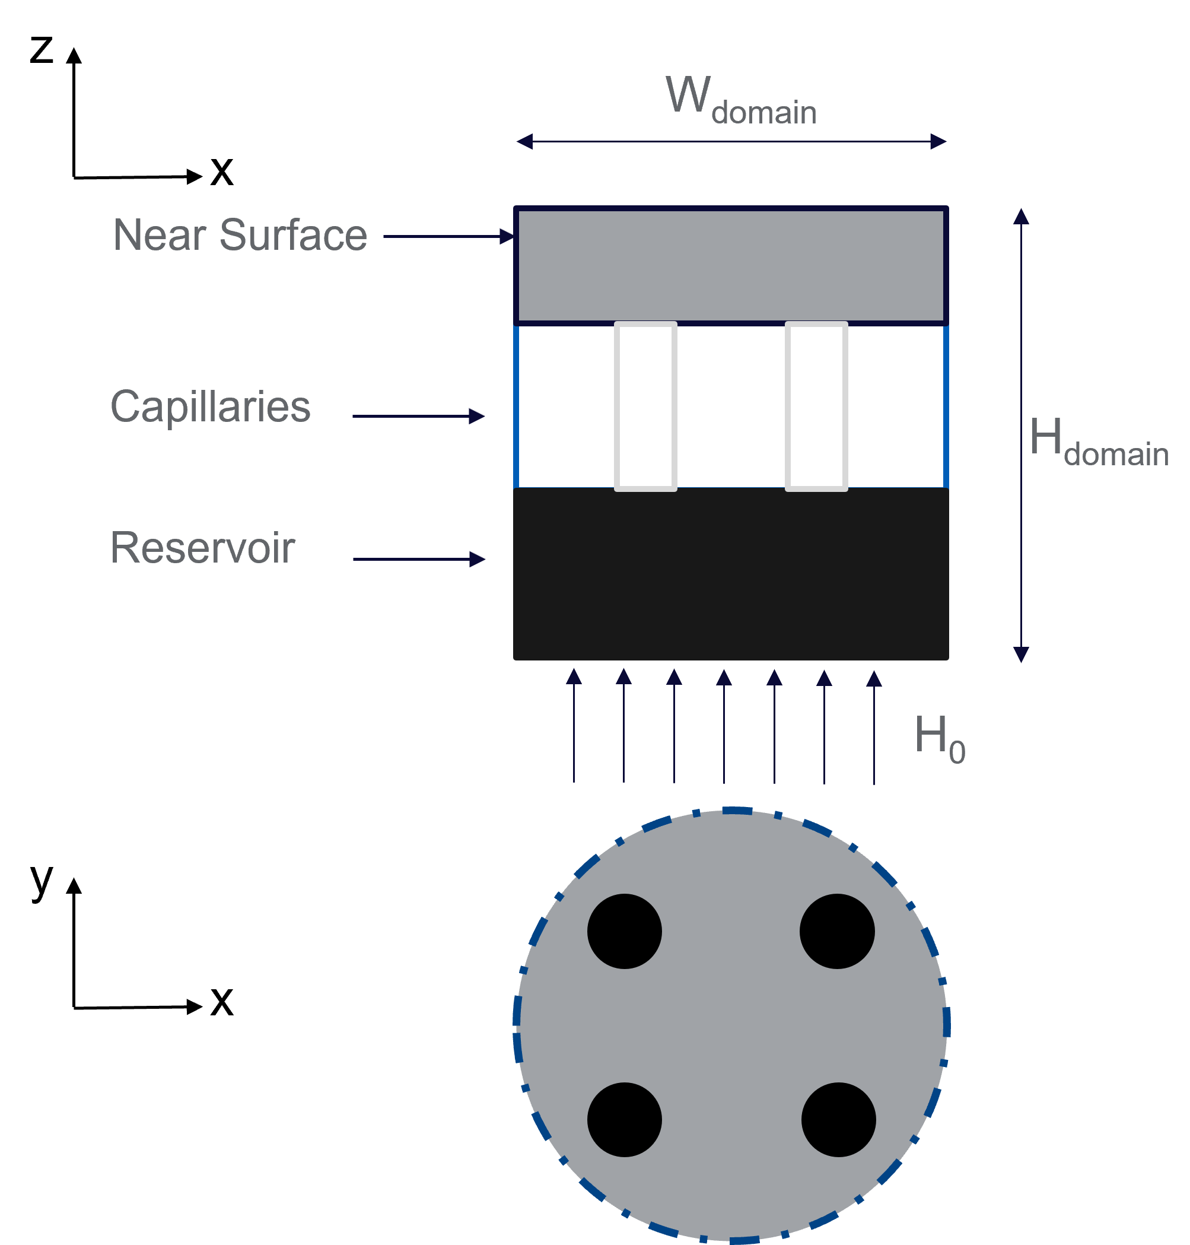

Figure 35. Schematic of COMSOL simulation setup

The liquid mirror setup consists of three layers namely reservoir (ferrofluid) layer, capillaries (porous) layer and near surface (liquid mirror) layer shown in Figure 35. The ferrofluid in the reservoir rises up in the porous media due to capillary force and fills the near surface layer. The system consists of two fluids (ferrofluid and air) and modeled as a two-phase flow model. The velocity of the fluids is very low and Reynolds number is less than 10. Therefore, laminar Navier-Stokes equation is used as given in EQ (1).

$∇.u=0$ (1)

$ρ\frac{Du}{Dt}=-∇p+∇.τ+F_{σ}+F_{m}$ (2)

where,

$τ= \left[η\left(∇u+ {\left(∇u\right)}^{T}\right)\right]$: $F_{σ}= ∇.\left[σ\left\{I+ \left(-{nn}^{T}\right)\right\}δ\right]$

For multi-phase modeling, level-set method is used. The phase term is defined as ϕ which takes value between 0 and 1. For ferrofluid ϕ = 1 and for air ϕ = 0. The phase dependent material properties and fluid interaction is given as:

|  |  |
| --- | --- |
| Density: $$ρ=ρ_{a}+\left(ρ_{ff}-ρ_{a}\right)ϕ$$ Kinematic viscosity: $η=η_{a}+\left(η_{ff}-η_{a}\right)$ $ϕ$ | Dynamic viscosity: $$μ=μ_{a}+\left(μ_{ff}-μ_{a}\right)ϕ$$ Magnetic susceptibility: $χ=χ_{a}+\left(χ_{ff}-χ_{a}\right)$ $ϕ$ |

$\frac{dϕ}{dt}+∇.\left(uϕ\right)=γ∇.\left(ε∇ϕ-ϕ\left(1-ϕ\right)\frac{∇ϕ}{\left|∇ϕ\right|}\right)$ (3)

The multi-physics for the current system is modeled by combining the gravitational force and electromagnetic force into N-S equations. The *Fm* in EQ (2) is volumetric electromagnetic force acting on the ferrofluid. The electromagnetic force is given as

$$∇.B=0, ∇×H=0, M=χH$$

$$B=μ_{0}\left(H+M\right)=μ_{0}\left(1+χ\right)H$$

$F_{m}=∇.τ_{m}=∇.\left(μ{HH}^{T}-\frac{μ}{2}H^{2}I\right)$ (4)

The magnetic and material properties of the ferrofluid is assumed to be linear and homogeneous. The flow of the ferrofluid inside the porous media is modeled using Darcy’s law. The velocity of the fluid is given as

$u=-\frac{k}{μ}∇p$ (5)

Two dimensionless numbers are used to study the performance of the system are given as

Capillary number (*Ca*) = $\frac{η_{a}R_{0}\dot{γ}}{σ}$ = $\frac{viscous force}{capillary force}$ (6)

Magnetic bond number (*Bom*) = (7)

Based on the previous experience of the collaborators, EFH1 is selected as the working ferrofluid for the current system. The selected ferrofluid is oil based. The properties of EFH1 is shown in Table 5**Error! Reference source not found.**.

|  |  |
| --- | --- |
| **Ferrofluid properties** | |
| Carrier liquid | Light mineral oil |
| Saturation magnetization | 440 Gauss (44 mT) |
| Viscosity @27οC | 6 cp (6 mPa.s) |
| Nominal particle diameter | 10 nm |
| Initial magnetic susceptibility | 2.58 Gauss/Oe (0.17 emu/g /Oe) |
| Relative magnetic permeability @ 20 Oe | 2.6 |
| Density | 1.21 g/ml (1.21 X 103 kg/m3) |
| Magnetic particle concentration | 7.9% by volume |
| Surface tension | 29 dynes/cm (29 mN/m) |
| Volatility (1hr @ 50οC) | 9% |

Table 5. Ferrofluid (EFH1) properties

The COMSOL simulation is setup to study the interaction of ferrofluid with the applied EM field. For the study, a droplet of ferrofluid is place in a constant magnetic field of 225G. The domain is modeled as axisymmetric to reduce the computational time. The response of the ferrofluid under applied magnetic field is shown in Figure 36. At time t=0, the droplet is assumed to have the shape with surface tension. With the applied magnetic field, the droplet holds a curved position. Without the magnetic field, the droplet would have responded to the gravity and gone flat as shown in Figure 37. It is observed that the current setup of simulation showed a successful interaction between the ferrofluid and applied EM field.

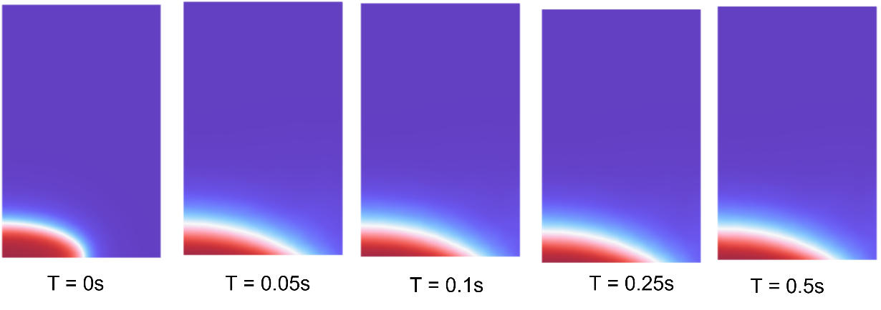

Figure 36. Interaction of ferrofluid with applied EM field

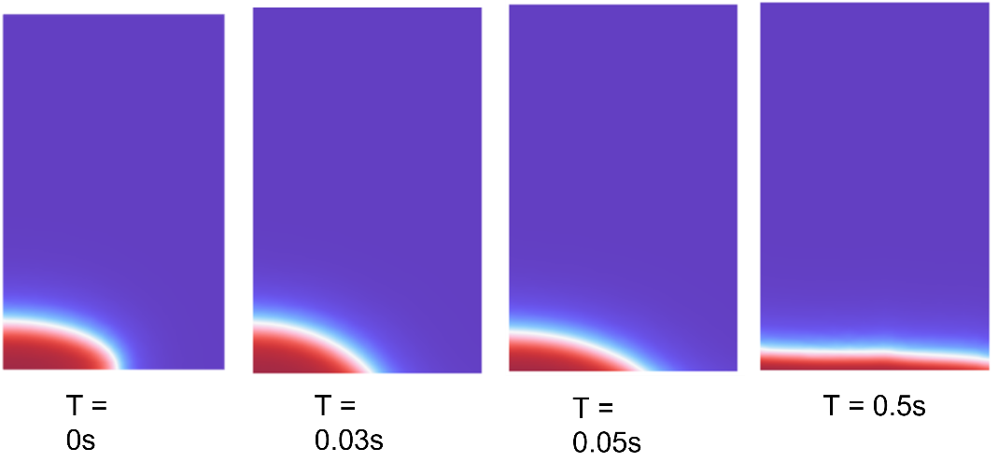

Figure 37. Interaction of ferrofluid with gravity (no EM field)

The simulation is carried out with Multiphysics simulation combining Darcy’s law and phase transport in porous media model. The phase transport in porous media uses separate volume fraction si for the wetting and nonwetting fluid i:

$\frac{∂}{∂t}\left(ε_{P}ρ_{i}s_{i}\right)+∇.\left({-ρ}_{i}κ\frac{κ_{ri}}{μ_{i}}\left({∇p}_{i}-ρ_{i}g\right)\right)=Q_{i}=0$ (1)

where, εp is the porosity, κ is the permeability (m2), κri is the relative permeability (a function of saturation for a given fluid), μi is the fluid’s dynamic viscosity (Pa.s), pi is the pressure (Pa), and ρi is the fluid density (kg/m3) of phase i.

The sum of the volume fraction of the two phases is 1, the remaining volume fraction is computed from

$s_{1}=1-s_{2}$ (2)

The capillary pressure pc is calculated as a function of the saturation of the wetting phase sw (which is s2 in the model) and the entry capillary pressure pec. By using the Brooks and Corey model, the capillary pressure is given by:

$p_{c}=p_{ec}\frac{1}{{\left(\overline{s_{w}}\right)}^{1/{λ_{p}}}}$ (3)

where, λp is the pore distribution index.

The relative permeabilities for the wetting and nonwetting phases, based on the Brooks and Corey model, are given by

$κ_{rs_{w}}={\left(\overline{s_{w}}\right)}^{\left(3+2/{λ_{p}}\right)}$ (4)

$κ_{rs_{n}}={\overline{s_{n}}}^{2}({1-(1-\overline{s_{n}})}^{(1+2/{λ_{p}})})$ (5)

The Darcy’s Law interface combines Darcy’s law with the continuity equation:

$\frac{∂}{∂t}\left(ρε_{p}\right)+∇.ρ\left[-\frac{κ}{μ}\left(∇p\right)\right]=0$ (6)

where density ρ and dynamic viscosity μ are average values of the two wetting and nonwetting fluids.

The effect of capillary forces on the ferrofluid is simulated and shown in Figure 38. For the current simulation, a porous media with 5mm diameter and 6mm height is used. It is observed that the given porous media is filled with ferrofluid within 6s.

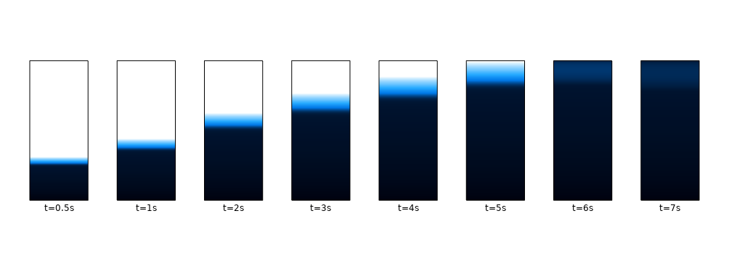

Figure 38. Ferrofluid saturation in porous media

The amount of ferrofluid absorbed by the porous media over time from the simulation is compared with the analytical solution. The fluid saturation in the porous media is analytically calculated using the Lucas-Washburn equation in EQ (7) shows the comparison of the results between the COMSOL simulation and analytical solution. The simulation result showed a good agreement with the analytical solution in Figure 39.

$H_{lf}=\sqrt{\frac{γR_{c}cosΘ}{2μ_{ff}}}$ (7)

where, γ is the surface tension, Rc the pore radius, Θ the contact angle, and μff  is the dynamic viscosity of the ferrofluid.

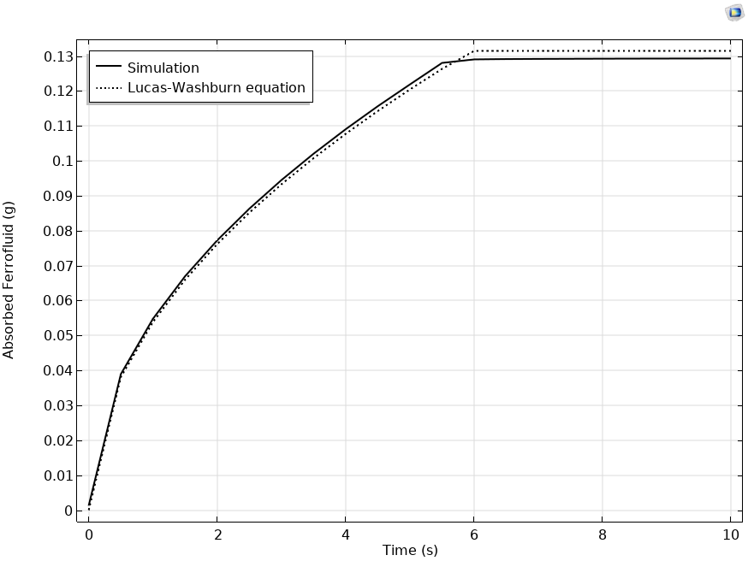

Figure 39. Ferrofluid saturation in the porous media over time

Ferrofluid under one actuation coil: The response of the ferrofluid with one actuation coil is simulated in COMSOL and an analytical solution is calculated in MATLAB. For the simulation, an actuation of coil of 32mm diameter and 32mm of height with 96 turns is used. The ferrofluid accumulated near the center of the coil (shown in Figure 40). The COMSOL result showed good agreement with the MATLAB analytical solution (shown in Figure 41).

80 mm

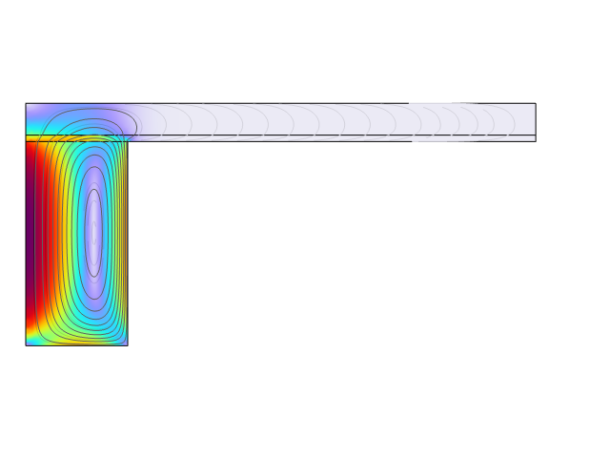

16 mm

32 mm

coil

ferrofluid

**Magnetic field distribution**

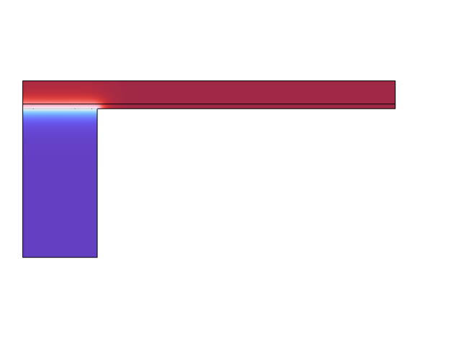

**Ferrofluid distribution**

**(at the end of simulation)**

air

ferrofluid

coil

(a)

(b)

Figure 40. (a) Magnetic flux distribution of the actuation coil and (b) volume fraction of the ferrofluid

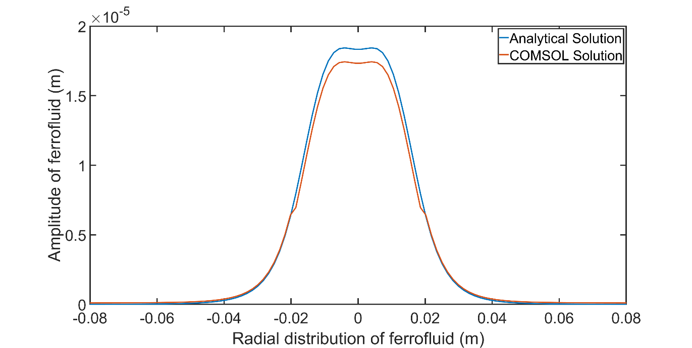

Figure 41. Comparison of ferrofluid response

For the current analysis, a theoretical Helmholtz coil is selected, and the design configuration is given in Table 6.

|  |  |
| --- | --- |
| **Design parameters** | **Values** |
| No of coils | 2 |
| Radius of the coil | 100 mm |
| Distance between the coils | 100 mm |
| Coil current | 100 A |
| No of coil turns | 100 |

Table 6. Design parameters of Helmholtz coil

Figure 42 shows the simulation domain and magnetic field generated in 2D and 3D domains. The spherical boundary of the simulation domain is defined as infinite elements. The infinite elements domain reduces the volume the envelop required by insulating the external magnetic field interference. Comparing the magnetic field generated in 2D is half the magnitude of the 3D domain. It attributed by the fact the 2D domain is simulating only one half the domain. This can be rectified by introducing the coil factor (2 for the current setup) in the simulation input. The 2D domain generates the same background magnetic field as 3D domain with reduced computational cost.

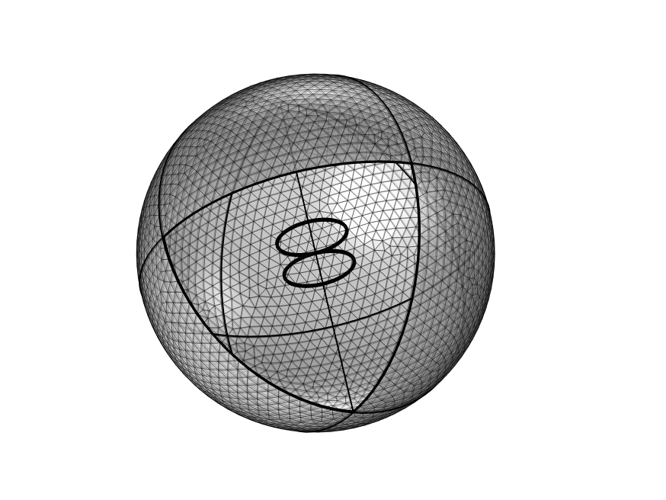

Simulation domain

Helmholtz coil

(a)

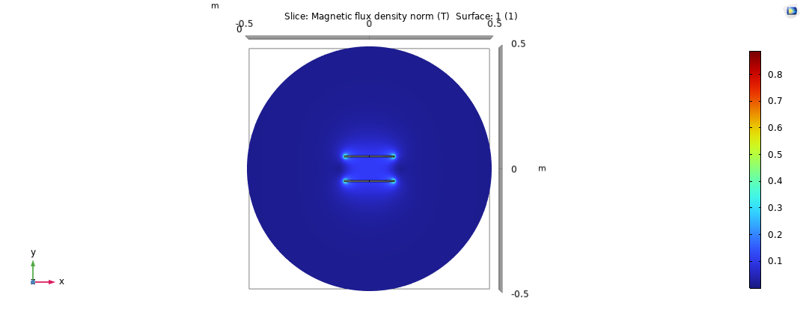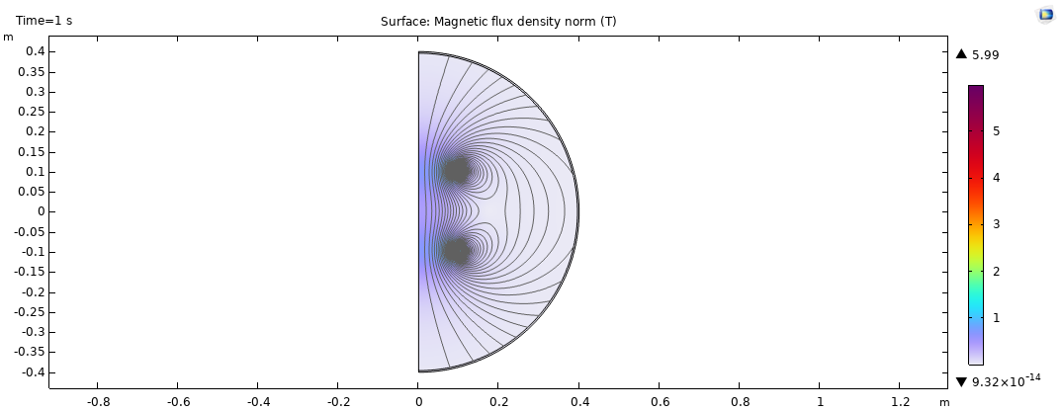

(b) (c)

Figure 42. Simulation domain of Helmholtz coil, (b) Background magnetic field generated in 3D domain and (c) magnetic field generated in 2D domain

**Response of ferrofluid in tilt plane:** Under tilt condition of the current setup, the gravitational force is not perpendicular to the plane of interest. The ferrofluid is subject to component of gravitation force. The response of the ferrofluid is analyzed for two different tilt conditions. First the inclination of the plane is kept constant, and the response of the ferrofluid is observed. As expected, the ferrofluid started sliding to the lower level of the plane. In the second case, an angular velocity of 1 deg/s is applied to the plate. In this case, the ferrofluid experienced additional force due to angular velocity along with gravitational force. Comparing both scenarios, the ferrofluid in tilt plane with angular velocity showed delayed flow rate towards lower level. Figure 43 shows the response of ferrofluid in tilt plane conditions.



Figure 43. Response of ferrofluid on tilt plane

## Example Cases

### 2D COMSOL of simulation of the mirror

Three different simulation cases were conducted to analyze the impact of porous media on the response of a single coil system. In Figure 44, the first case involved the presence of ferrofluid and EM coil without porous media in the system. On the left side of the figure, the volume fraction of the ferrofluid at the simulation's conclusion is displayed. The red line indicates the top surface location of the ferrofluid at the end of the simulation, demonstrating deformation in response to the magnetic field generated by the EM and Helmholtz coils. The right side of the figure illustrates the magnetic field generated by the EM and Helmholtz coils.

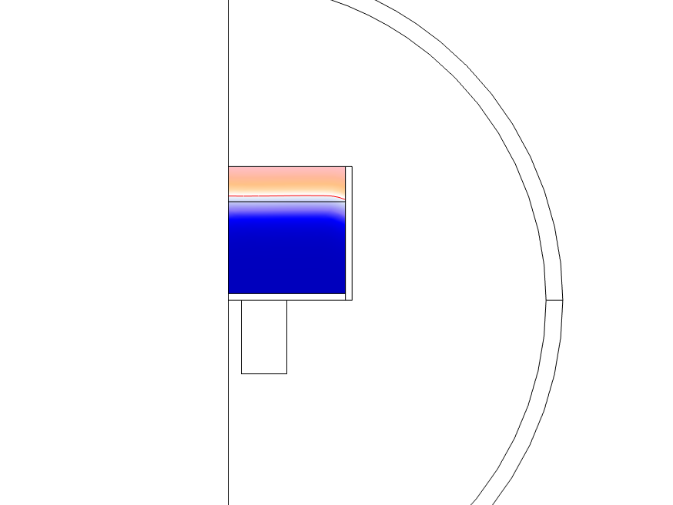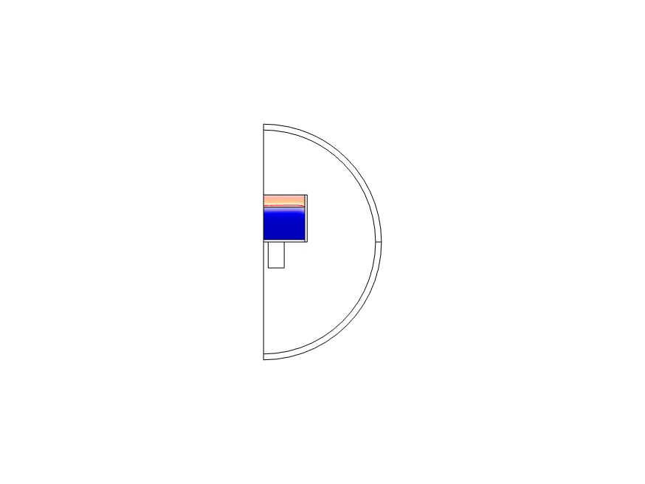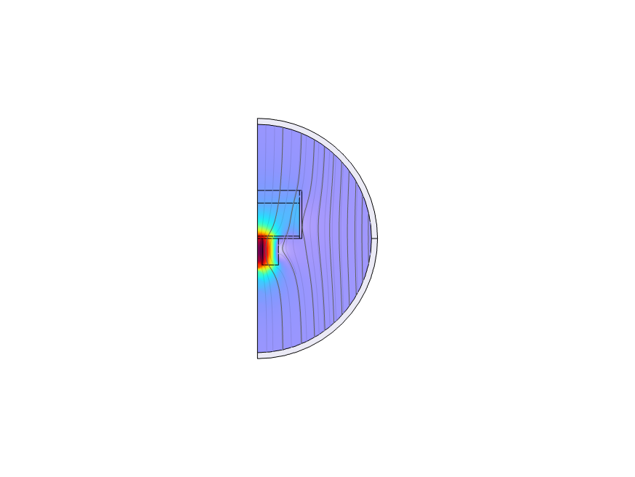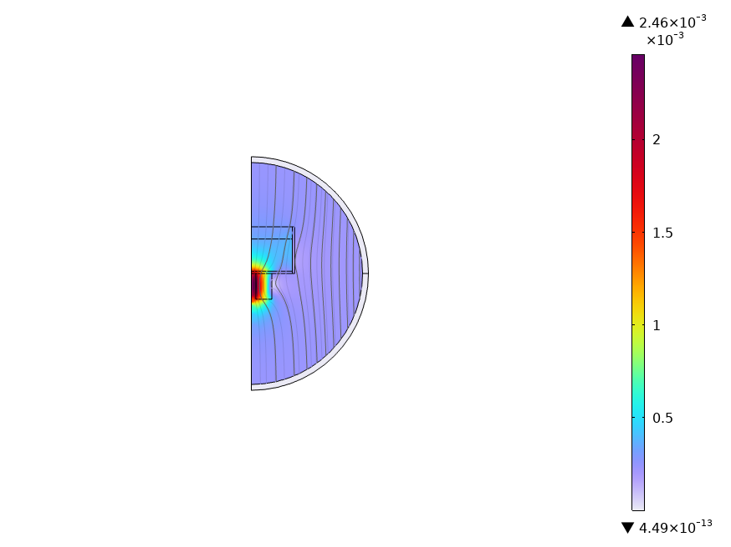

Figure 44. COMSOL simulation results – Ferrofluid and EM and Helmholtz coils (no porous media)

In Figure 45Figure *44*, the second case involved the presence of ferrofluid and porous media without magnetic field from EM and Helmholtz coils in the system. he results indicate that the ferrofluid top surface rises to meet the top surface of the porous media, due to the capillary forces.

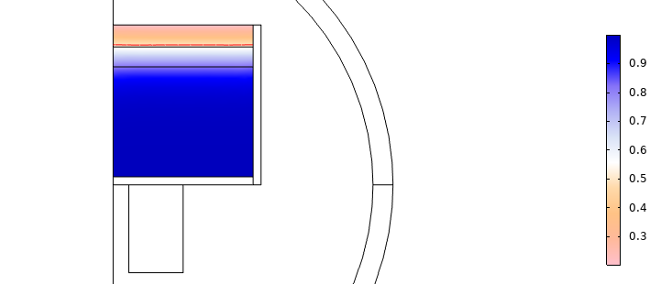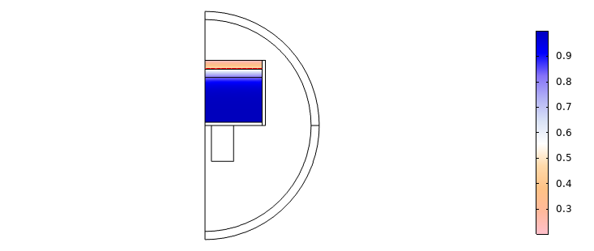

Figure 45. COMSOL simulation results – Ferrofluid and porous media (no magnetic field applied)

In Figure 46Figure *44*, the third case includes ferrofluid, porous media, and magnetic fields form EM and Helmholtz coils. The current inputs to the EM coil and Helmholtz coil are 0.1 A and 100 A, respectively. The magnetic field plot on the right side shows the maximum magnetic field amplitude of 2.46 Gauss. The volume fraction result and the top surface line of the ferrofluid (indicated by the red line) on the right side of the figure indicate that, under the given operating conditions and design parameters, the ferrofluid does not rise above the porous media.

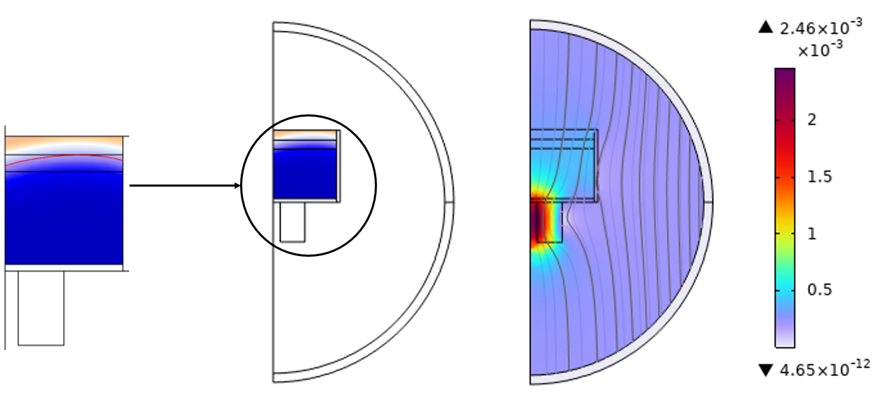

Figure 46. COMSOL simulation results – Ferrofluid, porous media, and Magnetic field (2.25 Gauss of magnetic field from Helmholtz coil)

In Figure 47Figure *44*, The fourth case incorporates ferrofluid, porous media, and magnetic fields from both the EM and Helmholtz coils, with the magnetic field strength from the Helmholtz coil increased from 2.25 Gauss to 22.5 Gauss. The volume fraction results on the right indicate that even with the increased magnetic field of 22.5 Gauss, the ferrofluid remains unable to rise above the porous media.

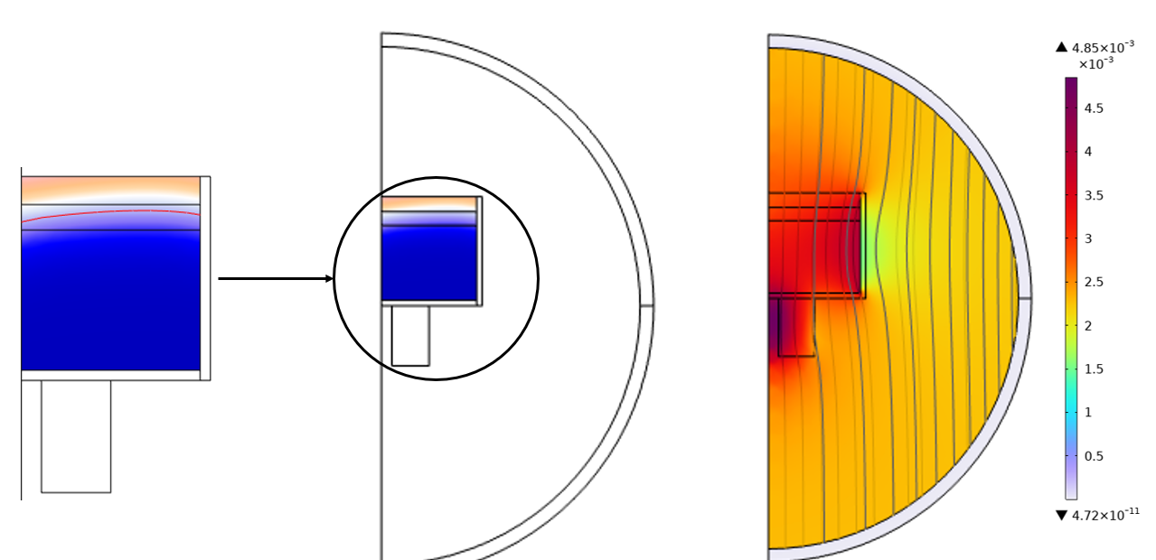

Figure 47. COMSOL simulation results – Ferrofluid, porous media, and Magnetic field 22.5 Gauss of magnetic field from Helmholtz coil)

## Simulation Model Validation with Experimental Results

Figure 48. Experimental setup to measure the ferrofluid surface profile

To validate the multiphysics simulation results from COMSOL, an experimental rig was set up as shown in Figure 48. The ferrofluid (EFH1) is placed inside a Maxwell coil (a configuration of 3 large coils) and on top of a small EM coil. A Shack-Hartmann sensor is used to measure the surface profiles of the ferrofluid while both the EM coil and Maxwell coil apply magnetic fields to induce surface deformation in the ferrofluid.

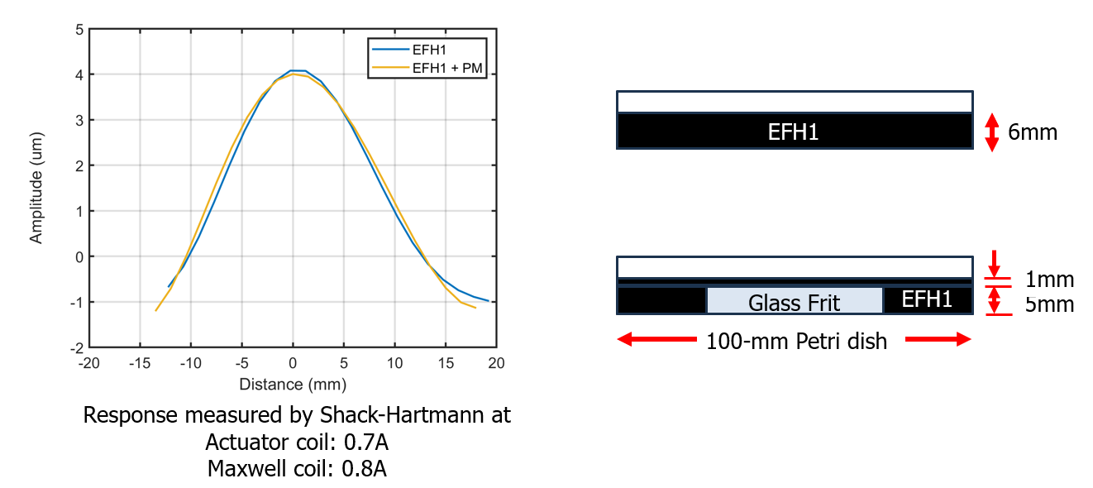

Figure 49. Measured surface profiles of ferrofluid with and without porous media

Figure 49 shows the experimental setup for the ferrofluid with and without porous media along with the surface profile measurements from the Shack Hartmann sensor. The EFH1 ferrofluid is placed inside a 100-mm Petri dish, as shown in the figure, with a maintained thickness of 6mm. The distance from the top of the EM coil surface to the top surface of the ferrofluid is set to 11mm.

For experiments with porous media, a glass frit material with a thickness of 5mm is placed inside the Petri dish, as shown in the figure. The EFH1 is then filled into the dish, and an additional 1mm layer of EFH1 is added on top of the glass frit to match the dish bottom to EFH1 top surface distance of 6mm for the tests cases with and without porous media.

The response diagram on the left of Figure 49 shows the measured surface profiles of EFH1 with and without porous media. For the experiments, 0.7 A was applied to the actuator coil and 0.8 A to the Maxwell coil. The results indicate that the surface deformation shape and its maximum displacement are quite similar at around 4 μm, regardless of the presence of the porous media.

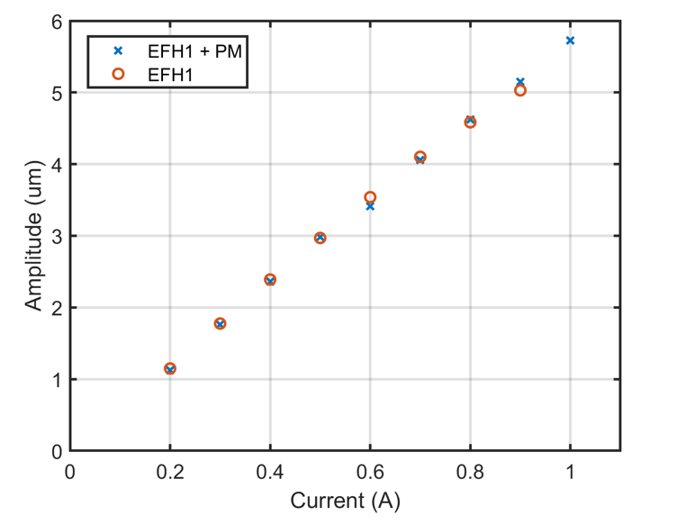

Figure 50. Measured maximum amplitude of ferrofluid surface with different EM coil currents

The maximum amplitudes of the EFH1 surface with different EM coil currents are measured and presented in Figure 50. The EM coil current inputs were varied from 0.2 A to 1 A. The results show that the maximum surface amplitude increases almost linearly from 1 μm to 5.8 μm with increasing EM currents. The trend in amplitude change was nearly identical between the cases with and without porous media.

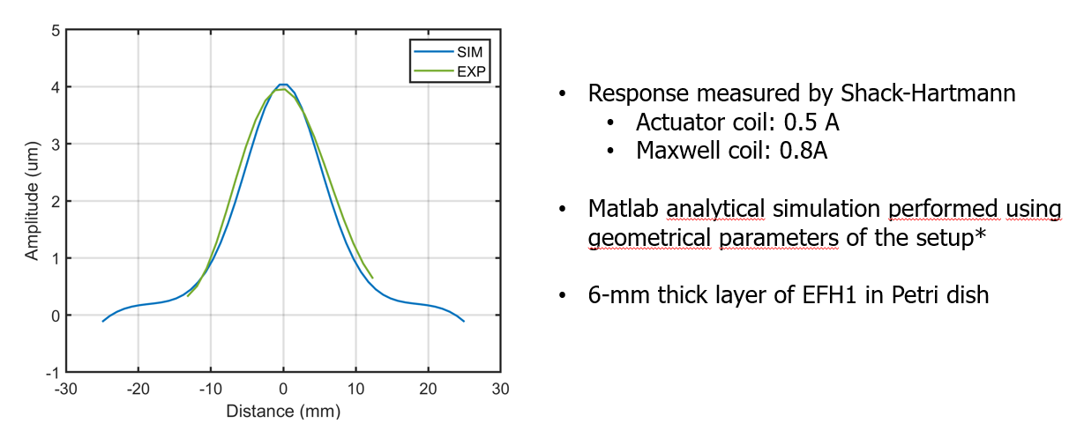

Figure 51. Comparison of ferrofluid surface profiles between simulation using analytical code and experiments

Figure 51 shows the comparison of surface profiles between the measured data and the simulation results using a MATLAB analytical model. An EM coil current of 0.5 A and a Maxwell coil current of 0.8 A were applied to both the experimental setup and the analytical models. The thickness of the EFH1 layer in the Petri dish was maintained at 6mm for both cases. The simulation results from the MATLAB analytical model shows good agreement with the measured EFH1 surface profile obtained using the Shack-Hartmann sensor.

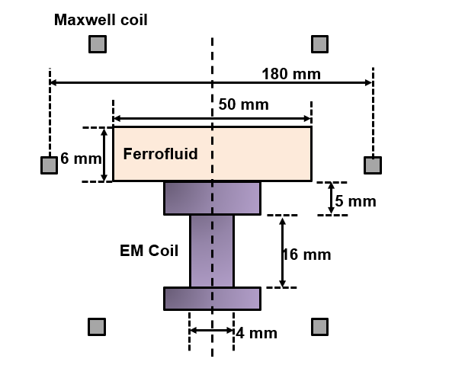

Figure 52. Simulation setup for 2D Multiphysics simulation using COMSOL

Figure 52 shows the simulation setup for the 2D Multiphysics simulation using COMSOL, which mimics our experimental setup. The size of the EM and Maxwell coils matches the experimental setup. The distance between the EM coil windings and the ferrofluid is also maintained at 11mm, aligning with the experimental setup.



Figure 53. Mesh convergence tests for 2D COMSOL simulation

Figure 53 shows the mesh convergence tests of 2D COMSOL simulation models using the measured surface profiles from the experiments. Note that for this mesh convergence study, the distance between the top surface of EFH1 and the EM coil is 5mm, not 11mm. An EM coil current of 0.11 A was applied to both the simulation and experimental setups. Two different mesh sizes for EFH1 were used: 10 μm and 20 μm. With the larger mesh size of 20 μm, the comparison between the experiment and prediction showed a significant error at the center of the profiles, with a maximum amplitude difference of more than 2 μm. With the reduced mesh size of 10 μm, the error between the experiments and prediction was less than 0.3 μm. These results indicate that for accurate prediction of the ferrofluid surface deformation, a mesh size smaller than 10 μm is required in Multiphysics COMSOL simulations.

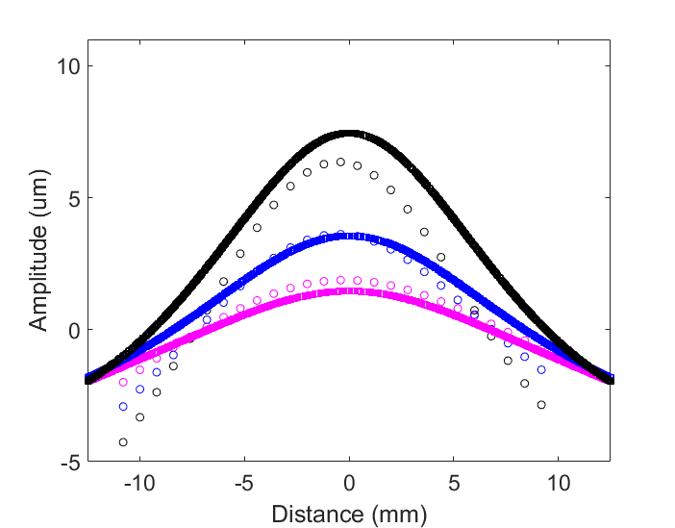

Test – 1A

Test – 0.5A

Test – 0.2A

SIM – 1A

SIM – 0.5A

SIM – 0.2A

Figure 54. Comparison between measured ferrofluid surface profiles and simulation results using 2D COMSOL simulation with different EM coil currents (10mm distance between ferrofluid top surface and EM coil)

Figure 54 shows the comparison between the measured EFH1 surface profiles and the 2D COMSOL simulation results with varying EM coil currents from 0.2 A to 1 A. Similar to the test results, where the surface amplitude increases from 2 μm to around 7.5 μm with increasing current, the simulation results showed a similar trend of increasing EFH1 surface deformation with increasing coil current. Note that for this mesh convergence study, the distance between the top surface of EFH1 and the EM coil is 10mm, not 11mm.

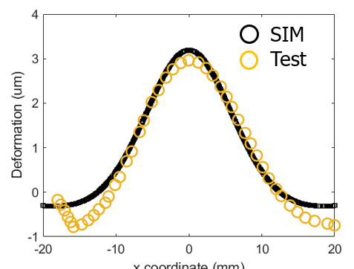

Figure 55. Comparison between measured ferrofluid surface profiles and simulation results using 2D COMSOL simulation with EM coil currents of 0.5 A (11mm distance between ferrofluid top surface and EM coil)

Figure 55 shows the comparison between the measured EFH1 surface profiles and the 2D COMSOL simulation with a distance of 11mm between the top surface of EFH1 and the EM coil. A 0.5 An EM coil current along with a 0.8 A Maxwell coil current input were used for both the simulation and the tests. The results show good agreement between the simulation and the tests, with the maximum surface amplitude being similar at around 3 μm. A mesh size of 5 μm for the EFH1 surface and the interfacing ambient air was used for the 2D COMSOL simulations.

# **Codes for system control**

## Summary of Code Deliverables

|  |  |  |  |
| --- | --- | --- | --- |
| **NO** | **Code title** | **Code outcomes** | **Software** |
| 1 | Single Coil Control | Bode and Step Response plots comparing the open loop and Closed loop system response of single coil dynamic system | MATLAB/Simulink |
| 2 | 7 coil MIMO Control | Bode and Step Response plots comparing the open loop and Closed loop system response of 7-coil MIMO dynamic system | MATLAB/Simulink |

Table 7. List of code deliverables-System control

## Details of Code Deliverables

### Single Coil Control

* **Execution file**: mainCompModel_SISO.m
* **Folder name that contains the execution file**: ‘Controls_Models’
* **Description**: The *MATLAB* and *Simulink* *(R2023b)* code in this folder generates the closed loop response for a unit cell LM system consisting of a single EM coil actuator and liquid wavefront deformation directly above the EM coil. The control scheme employs a PI (Proportional-Integral) Controller for reference tracking. The code generates plots comparing Bode plots and Step response plots for open loop (OL) and closed loop (CL) system.
* **Inputs**: Relative Permeability constant, Ferrofluid density, Current in the coil, Coil radius, Step input data
* **Outputs from codes**: Closed loop system response of ferrofluid center deformation to Step input data

### 7 Coil MIMO Control

* **Execution file**: mainCompModel_MIMO.m
* **Folder name that contains the execution file**: ‘Controls_Models’
* **Description**: The *MATLAB* and *Simulink* *(R2023b)* code in this folder generates the closed loop response for a 7-cell LM system consisting of 7 EM coil actuators and 7 liquid wavefront deformations directly above the corresponding EM coils while the mirror is subjected to tilt disturbance. The control scheme employs a decentralized PI (Proportional-Integral) Controller for reference tracking and disturbance rejection. The code generates plots comparing Step response plots for open loop (OL) and closed loop (CL) system.
* **Inputs**: Relative Permeability constant, Ferrofluid density, Location of active coils, Location of the displacement points
* **Outputs from codes**: Closed loop system response of ferrofluid deformation at 7 points corresponding to the points above the EM coils and disturbance rejection.

## Modeling Approach

Dynamic model characterization for a unit cell consisting of ferrofluid liquid film and an EM actuator was obtained from literature. This unit cell did not include mesoporous structure, which will be incorporated in the model at a later stage. Figure 56 shows the unit cell for which a dynamic model was obtained from literature [5]

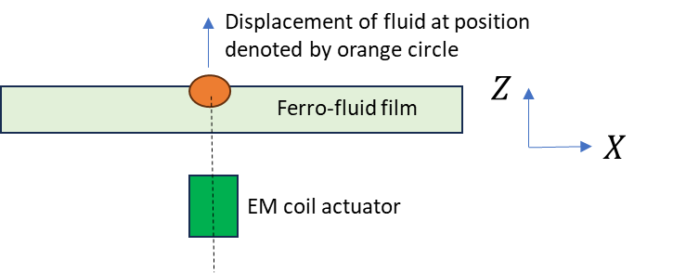

Figure 56. unit cell consisting of a ferrofluid film with an EM coil actuator. This configuration was used for characterizing the system model, where the transfer function between the z-axis fluid section height (shown as orange circle) due to an EM coil placed right below it, was obtained.

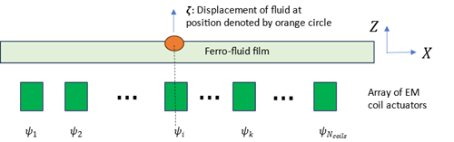

Figure 57. MIMO model configuration with arrays of EM coil actuators influencing the displacement at the fluid surface. The transfer function between the z-axis fluid section height (shown as orange circle) due to all the EM coils, was obtained.

The Multiple Input Multiple Output (MIMO) State Space model also obtained from literature [4] models the fluid deformation $ζ$ due to magnetic field $ψ$ due to any EM coil. The resulting model can be used to simulate the highly coupled response of the mirror surface to the magnetic field from multiple EM coils. The MIMO dynamic model is presented in a state space form:

$$\dot{x}=Ax+Bu$$

$$y=ζ=Cx$$

where state vector $x$, system matrices $A, B$ and $C$ are system matrices well defined in Eq 59in [4]. This model is defined as a spring mass damper system with damping due to fluid viscosity and spring action due to surface tension. The analytical expressions in the referred work use fluid parameters such as viscosity, surface tension, density, magnetic permeability etc.

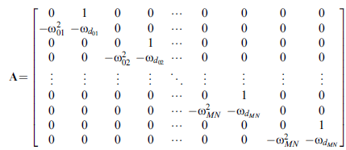

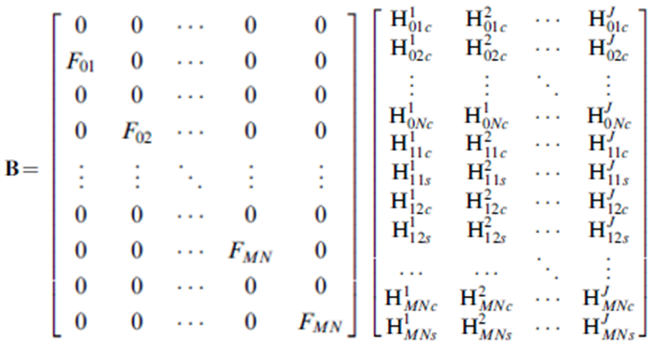

The model has the following assumptions:

* + EM coil actuators are treated as single point coils.
  + The boundary effects of liquid container are not considered.
  + EM coil dynamics are ignored as they are considered fast compared to liquid wavefront dynamics.
  + State Space model assumes the EM coils are far from the liquid container boundary.

## Example Cases

The current LM MIMO problem is modeled as a layer of Ferrofluid actuated by 7 EM coils. The EM coils are arranged in a hexagonal layout with coil-1 located at point (0,0). The magnetic field generated by the EM coils affects displacement at locations other than directly above the coil locations. The deformation locations are the blue dots in Figure 58 and the coils are the numbered circles.

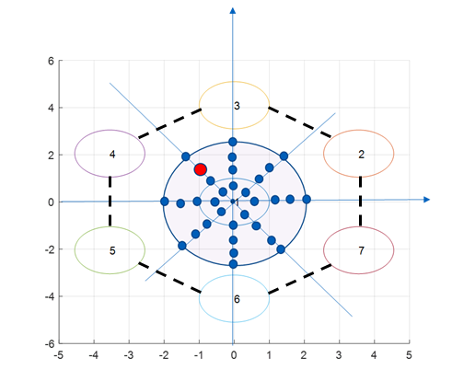

Figure 58. 7-unit cell configuration of 7-EM coils arranged in a hexagonal geometry

The system state space model was used and compared in 3 different configurations:

* Open Loop System and closed Loop System with a controller $K(s)$ for a single coil and the deformation directly above the coil: The controller, $K\left(s\right)$ was designed as a proportional integral (PI) controller.

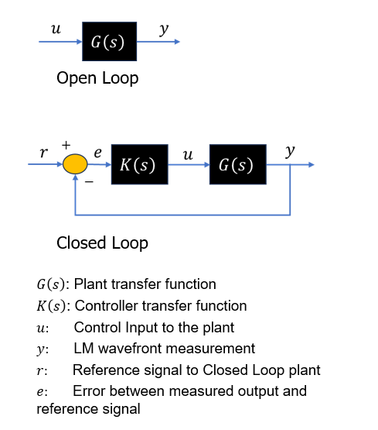

Figure 59. shows a block diagram configuration of open loop and closed loop.

* Closed Loop system with a controller $K(s)$ without tilt disturbance injected to the plant $G(s)$. The MIMO plant was decoupled to facilitate the development of the controller. The MIMO control problem was formulated as designing a set of SISO controllers. The decoupled system is used to implement a decentralized PI control. The resulting controller is the $K_{MIMO}\left(s\right)$ block.

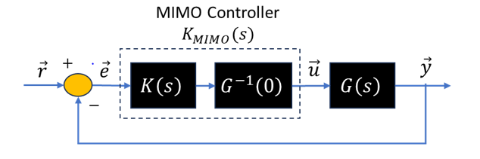

Figure 60. shows the block diagram configuration of the closed loop MIMO control with the decoupled control.

$G\left(s\right)$*: Plant’s MIMO transfer function matrix*

$K\left(s\right)$*: SISO Controller transfer function matrix*

$G\left(0\right)$*: Plant transfer function matrix at DC*

$K\left(s\right)$*: MIMO Controller transfer function matrix*

* Closed Loop system with a controller $K(s)$ and disturbance injected as $\vec{d}$ to the plant $G(s)$. The disturbance models the LM tilt which is injected as a ramp function input to the plant $G(s)$. The controller $K_{MIMO}\left(s\right)$, is designed to reject impact of disturbance, $\vec{d}$, while tracking reference input, $\vec{r}$.

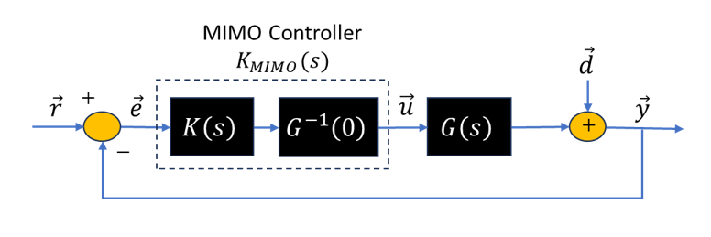

Figure 61. shows the block diagram configuration of the closed loop MIMO control with the decoupled control and disturbance rejection.

$\vec{d}:$***Tilt*** *as a disturbance to the plant output*

$\vec{y}:$*LM wavefront measurements*

$\vec{r}:$*Reference signals to Closed Loop plant*

$\vec{e}:$*Error between measured outputs and reference signals*

### Simulations

The bode plot of the open loop and closed loop system for a SISO model of EM coil-1 and the deformation directly above it is shown in Figure 62. The plot shows a 13 times bandwidth increase from Open Loop to Closed Loop: 0.6 Hz to 7.8 Hz.



Figure 62. Bode plots of open loop (OL) and closed loop (CL) transfer function

The MIMO open loop and closed loop system was simulated for reference signal tracking without disturbance injection. Closed loop regulation was applied at 7 deformation locations directly above the 7 EM coils. The system response is shown in Figure 63. Using the controller, the settling time of the response improved from 5.5s in open loop to 0.78s in closed loop.

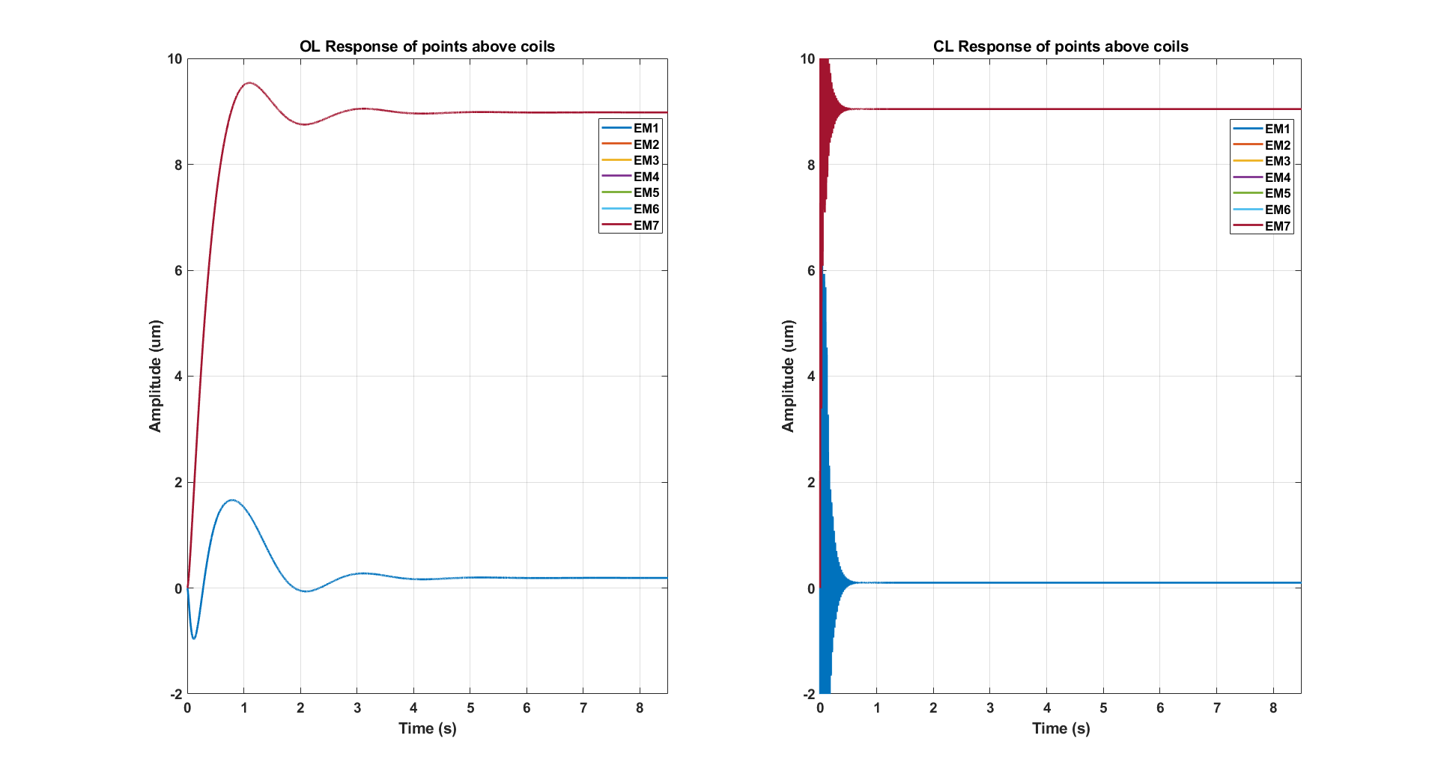

Figure 63. Simulation result showing comparison between LM system response to a ramp input disturbance injection with and without the controller.

Simulation was run by injecting a ramp input to the plant $G(s)$. A ramp function input simulated the impact of tilting the LM system. The response of the system with and without the controller is shown in Figure 64. It is clearly evident from the results in Figure 64, that using controller, we can reject (mitigate) the effect of disturbance due to tilt. This will be further tested by giving a tilt input at varying slew rates.

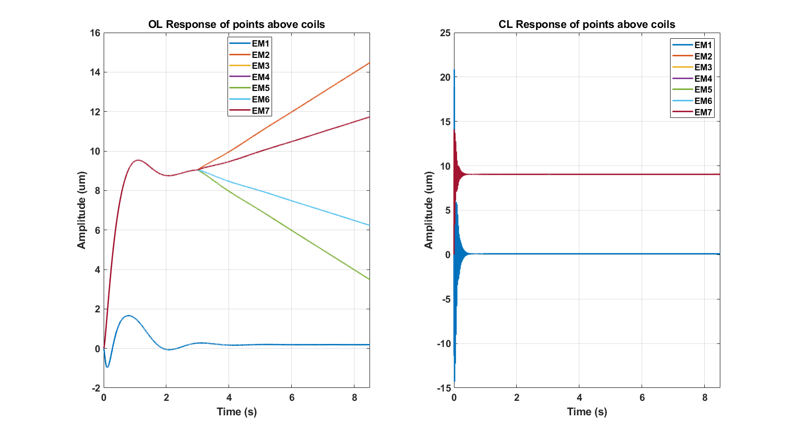

Figure 64. Simulation result showing comparison between LM system response to a ramp input disturbance injection with and without the controller

## Example Cases

### FDM model

This code generates Bode and Step response plots comparing the work of Azhar Iqbal and Denis Brousseau. The Figure *65* below show step response plot generated by running the main script.

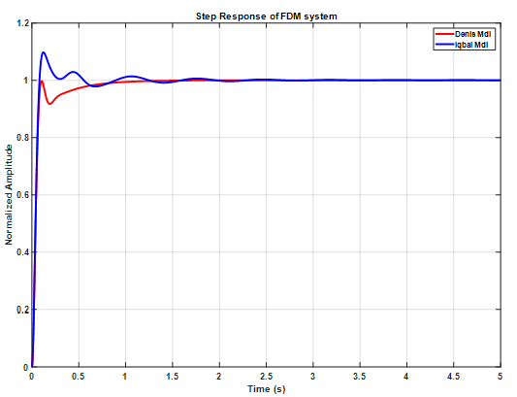

Figure 65. Step response of single coil: comparison between model from Azhar Iqbal and Denis Brousseau

### Single Coil Control

This code generates Bode plots and Step Response plots comparing the open loop and Closed loop system response. Additionally, when run in Matlab, the code also generates performance metrics like Rise Time, Settling Time, overshoot and undershoot etc. An example plot produced by running the main script comparing multiple step response inputs for open loop and closed loop system is shown in Figure *66* below.

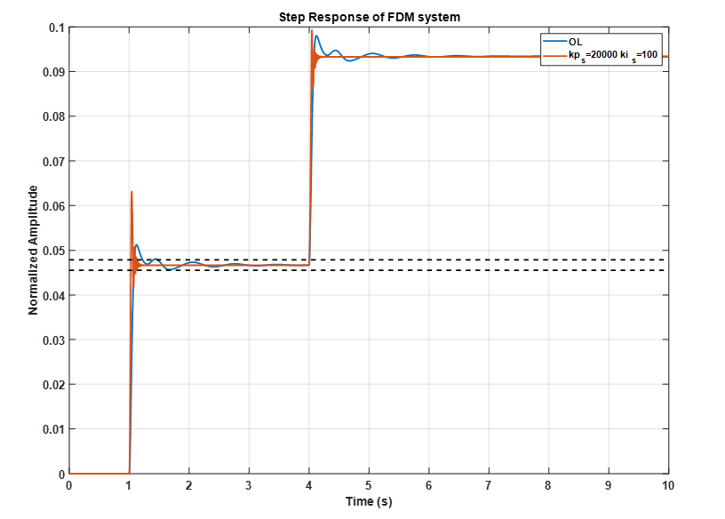

Figure 66. Open loop and Closed loop response of single coil to step input

# **Reference**

[1] Kyryushin, V. V. and Nazarenko, A. V., "Interaction of a magnetic liquid with a conductor containing current and a permanent magnet, " Fluid Dyn. 23, 306-311 (1988).

[2] Montgomery, Donald Bruce, and J. Terrell. Some Useful Information for the Design of Air-core Solenoids: Part I: Relationships Between Magnetic Field, Power, Ampere-turns and Current Density. Part II: Homogenous Magnetic Fields. National Magnet Laboratory, Massachusetts Institute of Technology, 1961.

[3] [Stan Zurek](https://www.e-magnetica.pl/doku.php/user/stan_zurek), Helmholtz coil, Encyclopedia Magnetica, <https://www.e-magnetica.pl/doku.php/helmholtz_coil>

[4] Iqbal, Azhar, and Foued Ben Amara. "Modeling and experimental evaluation of a circular magnetic-fluid deformable mirror." International Journal of Optomechatronics 2, no. 2 (2008): 126-143.

[5] Brousseau, Denis, Simon Thibault, Ermanno F. Borra, and Simon F. Boivin. "Modal dynamics of magnetic-liquid deformable mirrors." Applied optics 53, no. 22 (2014): 4903-4909.

# **Appendix: Source codes**

## Codes for Analytical models

### Influence function for unit cell – MATLAB

*Main Execution Function*

clc;clear all;close all;

[X,Y] = meshgrid(linspace(-0.08,0.08,100));

a = 2*[0.0175:-0.00081:0.0039]; % coil geometry - diameters of wires

h = [-0.066:0.00081:-0.032]; % coil geometry - heights of wires

current = 0.1;

offset = -0.035;

h = h + offset;

BX = 0; BY = 0; BZ = 0;

for i = 1:length(h)

for j = 1:length(a)

[bx,by,bz] = magloop(X,Y,0,a(j),h(i));

BX = BX + bx;

BY = BY + by;

BZ = BZ + bz;

end

end

ur = 2.7;

rho = 1210;

u0 = 4*pi*1e-7;

g = 9.8;

k = (ur-1)/(u0*ur*rho*g);

w = k*(ur*(BX).^2+ur*(BY).^2+(BZ).^2);

figure;

plot(X(50,:), current*BZ(50,:)*10000) % unit Gauss

xlabel('coordinates (m)')

ylabel('Magnetic Field (Gauss)')

figure;

plot(X(50,:), w(50,:)*1e6) % unit Gauss

xlabel('coordinates (m)')

ylabel('Deformation (um)')

*Magnetic loop function*

function [bx,by,bz] = magloop(x,y,z,a,h)

% a: coil radius

% h: coil vertical position?

r = sqrt(x.^2+y.^2)+eps; % distance to (x,y)

u0 = 4*pi*1e-7;

k = sqrt(4*a*r./((r+a).^2+(z-h).^2));

[K,E] = ellipke(k.^2);

b0 = u0*k./(4*pi*sqrt(a*r.^3));

br = -b0.*(z-h).*(K-E.*(2-k.^2)./(2*(1-k.^2)));

bx = br.*x./r;

by = br.*y./r;

bz = b0.*r.*(K+E.*(k.^2.*(r+a)-2*r)./(2*r.*(1-k.^2)));

### Helmholtz coils - MATLAB

*Main Execution Function*

clc;clear all;close all;

% Function that computes the influence matrices of an array of coil actuators located inside an Helmholtz coil

%

% INPUTS:

% actuator: Matrix containing the coil actuator geometry (nloops x 2)

% where nloops is the number of loops that the coil is made of,

% 1st column is the ith loop radius, and 2nd column is the ith loop z position

% nact: Number of actuators in the array (scalar)

% ax, ay: x and y coordinates of the actuators on the array in unit of the actuator diameter (1 x nact vectors)

% xdata, ydata: x and y coordinates at which the influence is calculated (vectors)

% * Use Matlab meshgrid function to create matrices then transpose to vectors

% * Number of data points is np

% OUTPUTS:

% infBx, infBy, infBz: Magnetic field influence functions (np x nact)

% bx_coil, by_coil, bz_coil: Values of the magnetic field components created by the Helmholtz coil (1 x np)

%

% PREREQUISITES: magloop.m

%

% initialiaze data

[X,Y] = meshgrid(linspace(-0.08,0.08,100));

xdata=X;

ydata=Y;

IdealCurrent=100;

% calculate magnetic field of Helmholtz coil

coil_top = [0.4 0.2]; % radius, height of 1st coil

coil_down = [0.4 -0.2]; % radius, height of 2nd coil

[bx_top,by_top,bz_top] = magloop(xdata,ydata,0,coil_top(1),coil_top(2));

[bx_down,by_down,bz_down] = magloop(xdata,ydata,0,coil_down(1),coil_down(2));

% add magnetic field components from 1st and 2nd coils

bx_coil = bx_top + bx_down;

by_coil = by_top + by_down;

bz_coil = bz_top + bz_down;

figure;

plot(X(50,:), IdealCurrent*bz_coil(50,:)*10000) % unit Gauss

xlabel('coordinates (m)')

ylabel('Magnetic Field (Gauss)')

*Magnetic loop function*

function [bx,by,bz] = magloop(x,y,z,a,h)

% a: coil radius

% h: coil vertical position?

r = sqrt(x.^2+y.^2)+eps; % distance to (x,y)

u0 = 4*pi*1e-7;

k = sqrt(4*a*r./((r+a).^2+(z-h).^2));

[K,E] = ellipke(k.^2);

b0 = u0*k./(4*pi*sqrt(a*r.^3));

br = -b0.*(z-h).*(K-E.*(2-k.^2)./(2*(1-k.^2)));

bx = br.*x./r;

by = br.*y./r;

bz = b0.*r.*(K+E.*(k.^2.*(r+a)-2*r)./(2*r.*(1-k.^2)));

### 271 EM coils with Helmholtz coil - MATLAB

*Main Execution Function*

clc;clear all;close all;

load act35mm.mat

load xAct.mat

load yAct.mat

load currentdistribution.mat

% Function that computes the influence matrices of an array of coil actuators located inside an Helmholtz coil

%

% INPUTS:

% actuator: Matrix containing the coil actuator geometry (nloops x 2)

% where nloops is the number of loops that the coil is made of,

% 1st column is the ith loop radius, and 2nd column is the ith loop z position

% nact: Number of actuators in the array (scalar)

% ax, ay: x and y coordinates of the actuators on the array in unit of the actuator diameter (1 x nact vectors)

% xdata, ydata: x and y coordinates at which the influence is calculated (vectors)

% * Use Matlab meshgrid function to create matrices then transpose to vectors

% * Number of data points is np

% OUTPUTS:

% infBx, infBy, infBz: Magnetic field influence functions (np x nact)

% bx_coil, by_coil, bz_coil: Values of the magnetic field components created by the Helmholtz coil (1 x np)

%

% PREREQUISITES: magloop.m

%

% initialiaze data

xdata=xAct;

ydata=yAct;

nact=271;

ax=act35mm(:,1);

ay=act35mm(:,2);

actuator=act35mm;

np = size(xdata,2);

nloops = size(actuator,1);

actdia = 0.035; % actuator diameter

actoffset = -0.035; % actuator offset

xact = ax*actdia; % x position of the actuators on the grid

yact = ay*actdia; % y position of the actuators on the grid

zdata = 0.125*(xdata.^2 + ydata.^2); % parabolic surface of data

zact = 0.125*(xact.^2 + yact.^2); % offset of the actuators to maintain uniform distance from parabolic surface

infBx = zeros(np,nact); infBy = zeros(np,nact) ; infBz = zeros(np,nact);

EMcurrent = 0.1;

HelmholtzCurrent = 100;

% calculate magnetic field of Helmholtz coil

coil_top = [0.4 0.2]; % radius, height of 1st coil

coil_down = [0.4 -0.2]; % radius, height of 2nd coil

[bx_top,by_top,bz_top] = magloop(xdata,ydata,zdata,coil_top(1),coil_top(2));

[bx_down,by_down,bz_down] = magloop(xdata,ydata,zdata,coil_down(1),coil_down(2));

% add magnetic field components from 1st and 2nd coils

bx_coil = bx_top + bx_down;

by_coil = by_top + by_down;

bz_coil = bz_top + bz_down;

% compute influence matrix

for i = 1:nact % iterate for each actuator

for j = 1:np % iterate through all data points

for k = 1:nloops % iterate through all current loops

zcoil = actuator(k,2) + zact(i) + actoffset;

[dBx,dBy,dBz] = magloop(xdata(j)-xact(i),ydata(j)-yact(i),zdata(j),actuator(k,1),zcoil);

infBx(j,i) = infBx(j,i)+dBx;

infBy(j,i) = infBy(j,i)+dBy;

infBz(j,i) = infBz(j,i)+dBz;

end

end

end

% physical constants

ur = 2.7; % magnetic permeability of the ferrofluid

rho = 1210; % density of the ferrofluid

u0 = 4*pi*1e-7; % magnetic permeability of vaccum

g = 9.8; % acceleration gravity

k = (ur-1)/(u0*ur*rho*g);

% compute deformation

w = k*(ur*(infBx.*Current'+ bx_coil*HelmholtzCurrent).^2+ur*(infBy.*Current' + by_coil*HelmholtzCurrent).^2+(infBz.*Current' + bz_coil*HelmholtzCurrent).^2);

figure;

scatter3(xAct,yAct,w(1,:)*1e6,[],w(1,:)*1e6);

colormap jet

view(2)

xlabel('X coordinates (m)')

ylabel('Y coordinates (m)')

a=colorbar;

ylabel(a,'Deformation (um)','FontSize',16,'Rotation',270);

*Magnetic loop function*

function [bx,by,bz] = magloop(x,y,z,a,h)

% a: coil radius

% h: coil vertical position?

r = sqrt(x.^2+y.^2)+eps; % distance to (x,y)

u0 = 4*pi*1e-7;

k = sqrt(4*a*r./((r+a).^2+(z-h).^2));

[K,E] = ellipke(k.^2);

b0 = u0*k./(4*pi*sqrt(a*r.^3));

br = -b0.*(z-h).*(K-E.*(2-k.^2)./(2*(1-k.^2)));

bx = br.*x./r;

by = br.*y./r;

bz = b0.*r.*(K+E.*(k.^2.*(r+a)-2*r)./(2*r.*(1-k.^2)));

### Influence of Coil diameters – 1D

*geometry1d_investigation_v4.py*

## 1D investigation

## this code has been a very quick endavour, not beautiful

## it has function for the complete mirror and fonction for ROI (smaller domain)

import numpy as np

import matplotlib.pyplot as plt

def gaussian(r,r0,s=1): # definition

return np.exp(-(r-r0)**2/(2*s**2))

def fig_gaus(dist,n): # display geometry of Gaussian distribution

cmap = plt.get_cmap('coolwarm')

j = 0

for i in dist:

color = cmap(j / len(dist))

for nn in np.linspace(i[0],i[-1],n,endpoint=True):

plt.plot(i, gaussian(i,0), linewidth=1, color="k")

plt.plot(i, gaussian(i,nn), linewidth=1, color=color)

j += 1

plt.title(f"{n:.0f} Gaussian responses")

plt.xlabel(r"Distance between Gaussian [$\sigma$]")

plt.ylabel("Normalized Intensity [-]")

plt.show()

for i in dist:

array = np.zeros_like(i)

for nn in np.linspace(i[0],i[-1],n,endpoint=True):

array = array + gaussian(i,nn)

plt.plot(i, array, linewidth=1, label= f"D = {np.max(i)*2/(n-1):.2f} $\sigma$")

plt.title(f"Sum of response of {n:.0f} Gaussians")

plt.xlabel(r"Distance between Gaussian [$\sigma$]")

plt.ylabel("Normalized Intensity [-]")

plt.legend()

plt.show()

def fig_gaus_ROI(dist,dist_ROI,n): # display geometry of Gaussian distribution over smaller domain

cmap = plt.get_cmap('coolwarm')

j = 0

x_lim=0

for d in range(len(dist)):

color = cmap(j / len(dist))

for nn in np.linspace(dist[d][0],dist[d][-1],n,endpoint=True):

# print(nn)

plt.plot(dist[d], gaussian(dist[d],0), linewidth=1, color="k")

plt.plot(dist[d], gaussian(dist[d],nn), linewidth=1, color=color)

if x_lim <= dist_ROI[d][-1]:

x_lim = dist_ROI[d][-1]

j += 1

plt.xlim(-x_lim,x_lim)

plt.title(f"{n:.0f} Gaussian responses")

plt.xlabel(r"Distance between Gaussian [$\sigma$]")

plt.ylabel("Normalized Intensity [-]")

# plt.legend()

plt.show()

for d in range(len(dist)):

array = np.zeros_like(dist[d])

for nn in np.linspace(dist[d][0],dist[d][-1],n,endpoint=True):

array = array + gaussian(dist[d],nn)

plt.plot(dist[d], array, linewidth=1, label= f"D = {np.max(dist[d])*2/(n-1):.2f} $\sigma$")

# plt.xlim(-x_lim,x_lim)

plt.title(f"Sum of response of {n:.0f} Gaussians")

plt.xlabel(r"Distance between Gaussian [$\sigma$]")

plt.ylabel("Normalized Intensity [-]")

plt.legend()

plt.show()

def response(pos,distance,s1=1,s2=1): # give mean and RMSE of the distribution

func = np.zeros_like(distance)

for p in pos:

func += gaussian(distance,p,s1)

mean = np.mean(func)

# erms = np.sqrt( np.trapz((func-mean)**2,distance)/np.trapz(1+0*distance,distance) )

erms = np.sqrt(np.mean(np.square(np.subtract(func,mean)))) # faster, same result

return mean, erms

def distance_array(xmin,xmax,step, n): # choosing a smaller domain for evaluation of performance

dist = []

if xmin == xmax:

dist.append(np.linspace(-xmin*(n-1)/2, xmin*(n-1)/2, 1000,endpoint=True))

else:

for i in np.arange(xmin,xmax,step):

dist.append(np.linspace(-i*(n-1)/2, i*(n-1)/2, 1000,endpoint=True))

return dist

def distance_array_ROI(xmin,xmax,step, n, frac): # choosing a smaller domain for evaluation of performance

dist = []

if xmin == xmax:

dist.append(np.linspace(-frac*xmin*(n-1)/2, frac*xmin*(n-1)/2, 1000,endpoint=True))

else:

for i in np.arange(xmin,xmax,step):

dist.append(np.linspace(-frac*i*(n-1)/2, frac*i*(n-1)/2, 1000,endpoint=True))

return dist

def pos_gaussian(dist, n): # gives the center position of the gaussian

return np.linspace(dist[0],dist[-1],n,endpoint=True)

def response_over_array(dist,n): #call functions

mean = []

erms = []

dd = []

for d in dist:

pos_gaus = pos_gaussian(d, n)

res = response(pos_gaus, d, s1=1,s2=1)

mean.append(res[0])

erms.append(res[1])

dd.append(np.max(d)*2/(n-1))

return [dd,mean,erms]

def response_over_array_ROI(dist,dist_ROI,n): #to compute over smaller domain

mean = []

erms = []

dd = []

for d in range(len(dist)):

pos_gaus = pos_gaussian(dist[d], n)

res = response(pos_gaus, dist_ROI[d], s1=1,s2=1)

mean.append(res[0])

erms.append(res[1])

dd.append(np.max(dist[d])*2/(n-1))

return [dd,mean,erms]

# main

n_gaussian = 7 #number of Gaussians (impair/odd)

d_min = np.sqrt(2*np.log(2)) # assuming diameter actuator = FWHM Gaussian hard limit

d_max = 2.5 # maximum distance between adjacent Gaussian

# display Gaussian

distx = distance_array(d_min,d_max,0.15,n_gaussian)

fig_gaus(distx,n_gaussian)

#computation

dist = distance_array(d_min,d_max,0.1,n_gaussian)

data = response_over_array(dist,n_gaussian)

# plt.plot(data[0],data[2])

# plt.title(f"RMSE of response of {n_gaussian:.0f} Gaussians")

# plt.xlabel(r"Distance between Gaussians [$\sigma$]")

# plt.ylabel("RMS error [-]")

# plt.show()

#find best filling for mirror

fraction = []

value = []

for frac in np.arange(0.5,1.01,0.1):

dist_ROI = distance_array_ROI(d_min,d_max,0.1,n_gaussian,frac)

data_ROI = response_over_array_ROI(dist,dist_ROI,n_gaussian)

plt.plot(data[0],data_ROI[2], label=f"{frac:.2f}")

fraction.append(frac)

value.append(data[0][np.argmin(data_ROI[2])]) # position of minimum of the curve

plt.title(f"RMSE of response of {n_gaussian:.0f} Gaussians using a fraction of the total mirror")

plt.xlabel(r"Distance between Gaussians [$\sigma$]")

plt.ylabel("RMSE of normalized intensity [-]")

plt.legend()

plt.show()

# plt.plot(data[0],data[1])

# plt.title(f"Mean value of response of {n_gaussian:.0f} Gaussians")

# plt.xlabel(r"Distance between Gaussians [$\sigma$]")

# plt.ylabel("mean [-]")

# plt.show()

# plt.plot(data[0],data_ROI[1])

# plt.title(f"Mean value of response of {n_gaussian:.0f} Gaussians flat ROI")

# plt.xlabel(r"Distance between Gaussians [$\sigma$]")

# plt.ylabel("mean [-]")

# plt.show()

plt.plot(value,fraction)

plt.title(f" Fraction of the mirror to be used when {n_gaussian:.0f} Gaussians with minimising the RMSE ")

plt.xlabel(r" Distance between Gaussians [$\sigma$]")

plt.ylabel(" Fraction used of the mirror [-]")

# plt.legend()

plt.show()

d_opt = data[0][np.argmin(data[2])]

dist_opt = distance_array(d_opt,d_opt,0.1,n_gaussian)

fig_gaus(dist_opt,n_gaussian)

print(r"minimal RMS error when distance =",d_opt,r"$\sigma $")

print(np.min(data[2]))

# frac = 0.5

# d_opt_ROI = data[0][np.argmin(data_ROI[2])]

# dist_opt_ROI = distance_array_ROI(d_opt_ROI,d_opt_ROI,0.01,n_gaussian, frac)

# fig_gaus_ROI(dist_opt_ROI,dist_opt_ROI,n_gaussian)

# print(r"minimal RMS error when distance =",d_opt_ROI,r"$\sigma $ flat ROI")

# fig_gaus_ROI(dist,dist_ROI,n_gaussian)

### Influence of Coil diameters – 2D

*geometry2d_investigation.py*

import numpy as np

import matplotlib.pyplot as plt

def rectangular_grid(rows, cols, spacing):

positions = []

for i in range(rows):

for j in range(cols):

positions.append([i * spacing, j * spacing])

return np.array(positions)

def triangular_grid(rows, cols, spacing):

positions = []

for i in range(rows):

for j in range(cols):

x = i * spacing

y = j * spacing if i % 2 == 0 else j * spacing + spacing / 2

positions.append([x, y])

return np.array(positions)

def hexagonal_grid(rows, cols, spacing):

positions = []

for i in range(rows):

for j in range(cols):

x = i * spacing * 1.5

y = j * spacing * np.sqrt(3)

if i % 2 == 1:

y += spacing * np.sqrt(3) / 2

positions.append([x, y])

return np.array(positions)

# Example usage:

rectangular_positions = rectangular_grid(rows=5, cols=5, spacing=1.0)

triangular_positions = triangular_grid(rows=5, cols=5, spacing=0.787)

hexagonal_positions = hexagonal_grid(rows=5, cols=5, spacing=0.5)

print("Rectangular Grid Positions:")

# print(rectangular_positions)

print(rectangular_positions[:,0])

plt.scatter(rectangular_positions[:,0],rectangular_positions[:,1])

plt.xlim(0,4)

plt.ylim(0,4)

plt.show()

print("\nTriangular Grid Positions:")

# print(triangular_positions)

plt.scatter(triangular_positions[:,0],triangular_positions[:,1])

plt.xlim(0,4)

plt.ylim(0,4)

plt.show()

# # print("\nHexagonal Grid Positions:")

# # print(hexagonal_positions)

# plt.scatter(hexagonal_positions[:,0],hexagonal_positions[:,1])

# plt.xlim(0,4)

# plt.ylim(0,4)

# plt.show()

def gaussian(x,y, x0, y0, s=1):

return np.exp(-( (x-x0)**2 + (y-y0)**2 ) / (2 * s**2))

# def fig_gaus(dist_x, dist_y, n):

# cmap = plt.get_cmap('coolwarm')

# j = 0

# for i, row in enumerate(dist_x):

# for nn, col in enumerate(dist_y):

# color = cmap(j / len(dist_x))

# plt.plot(row, gaussian(row, 0), linewidth=1, color="k")

# plt.plot(row, gaussian(row, col), linewidth=1, color=color)

# j += 1

# plt.title(f"{n:.0f} Gaussian responses")

# plt.xlabel(r"Distance between Gaussian [$\sigma$]")

# plt.ylabel("Normalized Intensity [-]")

# plt.show()

# for i, row in enumerate(dist_x):

# array = np.zeros_like(row)

# for nn, col in enumerate(dist_y):

# array = array + gaussian(row, col)

# plt.plot(row, array, linewidth=1, label=f"D = {np.max(row)*2/(n-1):.2f} $\sigma$")

# plt.title(f"Sum of response of {n:.0f} Gaussians")

# plt.xlabel(r"Distance between Gaussian [$\sigma$]")

# plt.ylabel("Normalized Intensity [-]")

# plt.legend()

# plt.show()

# def response(pos_x, pos_y, distance_x, distance_y, s1=1, s2=1):

# func = np.zeros_like(distance_x)

# for px, py in zip(pos_x, pos_y):

# func += gaussian(distance_x, px, s1) * gaussian(distance_y, py, s2)

# mean = np.mean(func)

# erms = np.sqrt(np.mean(np.square(np.subtract(func, mean))))

# return mean, erms

def distance_array(xmin, xmax, step, n):

dist = []

if xmin == xmax:

dist.append(np.linspace(-xmin*(n-1)/2, xmin*(n-1)/2, 1000, endpoint=True))

else:

for i in np.arange(xmin, xmax, step):

dist.append(np.linspace(-i*(n-1)/2, i*(n-1)/2, 1000, endpoint=True))

return dist

def pos_gaussian(dist, n):

return np.linspace(dist[0], dist[-1], n, endpoint=True)

# def response_over_array(dist_x, dist_y, n):

# mean = []

# erms = []

# dd = []

# for dx, dy in zip(dist_x, dist_y):

# pos_gaus_x = pos_gaussian(dx, n)

# pos_gaus_y = pos_gaussian(dy, n)

# res = response(pos_gaus_x, pos_gaus_y, dx, dy, s1=1, s2=1)

# mean.append(res[0])

# erms.append(res[1])

# dd.append(np.max(dx)*2/(n-1))

# return [dd, mean, erms]

# main

n_gaussian = 11

d_min = np.sqrt(2*np.log(2))

d_max = 2.5

# display Gaussian

dist_x = distance_array(d_min, d_max, 0.15, n_gaussian)

dist_y = distance_array(d_min, d_max, 0.15, n_gaussian)

# fig_gaus(dist_x, dist_y, n_gaussian)

# # computation

# dist_x = distance_array(d_min, d_max, 0.1, n_gaussian)

# dist_y = distance_array(d_min, d_max, 0.1, n_gaussian)

# data = response_over_array(dist_x, dist_y, n_gaussian)

# d_opt = data[0][np.argmin(data[2])]

# dist_opt_x = distance_array(d_opt, d_opt, 0.1, n_gaussian)

# dist_opt_y = distance_array(d_opt, d_opt, 0.1, n_gaussian)

# fig_gaus(dist_opt_x, dist_opt_y, n_gaussian)

# print(r"Minimal RMS error when distance =", d_opt, r"$\sigma$")

# print(np.min(data[2]))

### Magnetic field calculation of single tilted coil

*magnetic_field.py*

# modified from https://netdenizen.com/emagnet/offaxis/off_axis_loop.html

from scipy.special import ellipk, ellipe

from numpy import pi, sqrt, linspace, NaN

from pylab import plot, xlabel, ylabel, legend, show

import numpy as np

import matplotlib.pyplot as plt

uo = 4E-7*pi # Permeability constant - units of H/m

ur = 2.7 # relative Permeability constant - units of H/m

rho = 1210 # ferrofluid density - scaled

Bo = lambda i, a, u=uo: i*u/2./a # Central field = f(current, loop radius, perm. constant)

al = lambda r, a: r/a # Alpha = f(radius of measurement point, radius of loop)

be = lambda x, a: x/a # Beta = f(axial distance to meas. point, radius of loop)

ga = lambda x, r: x/r # Gamma = f(axial distance, radius to meas. point)

Q = lambda r, x, a: (1 + al(r,a))**2 + be(x,a)**2 # Q = f(radius, distance to meas. point, loop radius)

k = lambda r, x, a: sqrt(4*al(r,a)/Q(r,x,a)) # k = f(radius, distance to meas. point, loop radius)

K = lambda k: ellipk(k**2.0) # Elliptic integral, first kind, as a function of k

E = lambda k: ellipe(k**2.0) # Elliptic integral, second kind, as a function of k

# On-Axis field = f(current and radius of loop, x of measurement point)

def Baxial(i, a, x, u=uo):

if a == 0:

if x == 0:

return NaN

else:

return 0.0

else:

return (u*i*a**2)/2.0/(a**2 + x**2)**(1.5)

# Axial field component = f(current and radius of loop, r and x of meas. point)

def Bz(i, a, x, r):

if r == 0:

if x == 0:

return Bo(i,a) # central field

else:

return Baxial(i,a,x) # axial field

else: # axial component, any location

return Bo(i,a)*\

(E(k(r,x,a))*((1.0-al(r,a)**2-be(x,a)**2)/(Q(r,x,a)-4*al(r,a))) + K(k(r,x,a)))\

/pi/sqrt(Q(r,x,a))

# Radial field component = f(current and radius of loop, r and x of meas. point)

def Br(i, a, x, r):

if r == 0:

return 0 # no radial component on axis!

else: # radial component, any location other than axis.

return Bo(i,a)*ga(x,r)*\

(E(k(r,x,a))*((1.0+al(r,a)**2+be(x,a)**2)/(Q(r,x,a)-4*al(r,a))) - K(k(r,x,a)))\

/pi/sqrt(Q(r,x,a))

axiallimit = 0.2 # meters from center

radiallimit = 0.2 # maximum radius to investigate

curveqty = 101

X = linspace(0 ,axiallimit, curveqty)

R = linspace(-radiallimit, radiallimit, curveqty)

def deviation(current, dim_coil, z,r): #Eq 3.2

return (ur-1)*(Bz(current,dim_coil,z,r)**2+ Br(current,dim_coil,z,r)**2*ur)/(uo * ur* 9.81* rho)

def deviation2(current, dim_coil, z,r): #Eq 3.2 with tilted (fixed for the tilted case - not general)

fieldz2 = (Bz(current,dim_coil,z,r)**2 + (Br(current,dim_coil,z,r) * -0.002/0.035)**2)/(1+(-0.002/0.035)**2)

fieldr2 = (Bz(current,dim_coil,z,r) * (1 - 1/np.sqrt(1+(-0.002/0.035)**2)) )**2 + (Br(current,dim_coil,z,r) * (1 + (-0.002/0.035)/np.sqrt(1+(-0.002/0.035)**2)) )**2

return (ur-1)*( fieldz2 + fieldr2*ur)/(uo * ur* 9.81* rho)

plot(R, [deviation(1,0.035/2,0.03,np.abs(r)) for r in R], label="Flat")

# plot(R, [deviation(1,0.035/2,0.03-0.002*r/0.035,np.abs(r)) for r in R], label="Naive Tilted " , alpha = 0.8, linestyle= '--')

plot(R, [deviation2(1,0.035/2,0.03-0.002*r/0.035,np.abs(r)) for r in R], label="Tilted" , alpha = 0.8, linestyle= '-.')

xlabel("Position from the center of the coil [m]")

ylabel(r" $\Omega(x,y)$ [m]")

plt.title(r" Comparison of the expected ferrofluid surface deviation ($\rho=1210$ kg/m$^3$, $\mu_r=2.7$) from the "+"\n" +" magnetic field of a single coil (35mm diameter, 1A current, surface distance 30 mm at center) \n for a flat surface and a tilted surface of 2 mm over the coil ")

legend()

show()

# see tilted surface

plot(R, [0.03-0.001*r/(0.035/2) for r in R])

plt.vlines(-0.035/2,0,0.4)

plt.vlines(0.035/2,0,0.4)

plt.ylim(0.027,0.033)

plt.show()

## COMSOL Multiphysics simulation

All the files of COMSOL Multiphysics simulation are uploaded separately.

## Codes for system controller

### FDM Model - MATLAB

*Main Execution Function - mainCompModel_wDenisMdl.m*

clear all; close all; clc;

%% This is the main script to create state space model, transfer function

% and step response for MFDM (Magnetic Ferrofluid Deformable Mirror) system

% The model is developed based on the work of Dr. Azhar Iqbal's 2008 paper

% titled "Modeling and Exerimental Evaluation of a Circular Magnetic-Fluid

% Deformable Mirror" in International Journal of Optomechatronics.

% This paper is referred to as [Azhar 2008] in comments below

%

% Truncation parameters for Bessel function of first kind

M_bessel = 4; % an integer value >= 0

N_bessel = 4; % an integer value > 0

% Location of deformation measurement in polar coordinations

r_in = 0;

theta_in = 0;

% Location of EM coil in polar coordinates

r_coils_in = 0;

theta_coils_in = 0;

% Roots of Bessel function of first kind, J_m(E) = 0, m= 0,1,2, ...

E_orig = [2.405, 5.520, 8.654, 11.792, 14.931, 18.071, 21.212, 24.352, 27.493, 30.635;

3.832, 7.016, 10.173, 13.324, 16.471, 19.616, 22.760, 25.904, 29.047, 32.19;

5.136, 8.417, 11.620, 14.796, 17.960, 21.117, 24.270, 30.569, 33.717, 36.863;

6.380, 9.761, 13.015, 16.223, 19.409, 22.583, 25.748, 28.908, 32.065, 35.219;

7.588, 11.065, 14.373, 17.616, 20.827, 24.019, 27.199, 30.371, 33.537, 36.699;

8.772, 12.339, 12.339, 15.700, 18.980, 22.218, 25.430, 28.627, 31.812, 34.989;

9.936, 13.589, 17.004, 20.321, 23.586, 26.820, 30.034, 33.233, 36.422, 39.603;

11.086, 14.821, 18.288, 21.642, 24.935, 28.191, 31.423, 34.637, 41.031, 44.215;

12.225, 16.038, 19.555, 22.945, 26.267, 29.546, 32.796, 36.026, 39.240, 42.444;

13.354, 17.241, 20.807, 24.234, 27.584, 30.885, 34.154, 37.400, 40.629, 43.844];

E = E_orig(1:M_bessel+1, 1:N_bessel);

% Load parameters and compute lambda and z

run('modelParameters.m');

R = MdlParams.R;

lambda = E./R; % Eqn 43, [Azhar 2008]

h = MdlParams.EMcoil2filmDist;

z = -h;

% Compute Y and Z functions

Y = fnCompY(lambda, z, MdlParams); % function to compute Y, refer Eqn (35), [Azhar 2008]

Z = fnCompZ(lambda, z, MdlParams); % function to compute Z, refer Eqn (36), [Azhar 2008]

% Compute omega^2, F, Hmnc, Hmns, omega_d

omega2 = fnCompOmega2(Y, Z, lambda, MdlParams); % function to compute omega^2, refer Eqn (50), [Azhar 2008]

Fmn = fnCompF(lambda, Y, E, MdlParams); % function to compute Fmn, refer Eqn (52), [Azhar 2008]

[H0_coils, Hmnc_coils, Hmns_coils] = fnCompH_coils(lambda, E, r_coils_in, theta_coils_in); % function to compute H_mnc^j and H_mns^j,

% refer Eqn (53) and Eqn(56), [Azhar 2008]

omega_d = fnCompOmegad(lambda, MdlParams); % function to compute omega_d_mn, refer Eqn (58), [Azhar 2008]

[H0, Hmnc, Hmns] = fnCompH(lambda, r_in, theta_in); % function to compute H_mnc and H_mns, refer Eqn (44), [Azhar 2008]

% Compute A, B, C, D matrices

A = fnCompA(omega2, omega_d); % function to compute system's A matrix, Pg 135 after Eqn(59), [Azhar 2008]

B = fnCompB(Fmn, H0_coils, Hmnc_coils, Hmns_coils, length(r_coils_in)); % function to compute system's B matrix, Pg 135 & Pg 136after Eqn(59), [Azhar 2008]

C = fnCompC(H0, Hmnc, Hmns); % function to compute system's C matrix, Pg 136 after Eqn(59), [Azhar 2008]

D = zeros(length(r_in), length(r_coils_in)); % D matrix is 0 matrix

% Compute Transfer function, Bode plot and Step response

ss_value = 0.0467;

GG = tf(ss(A,B,C,D))*1/ss_value;

[y_m, t_m] = step(GG,5);

figure(1);

bode(GG);

title('Bode plot - Iqbal Mdl');

grid on

xlim([0.1,100])

%% Parameter's from Denis Brousseau's 2014 paper using simplified model

% Title: Modal dynamics of magnetic-liquid deformable mirrors

% Parameters

g1 = 0.135;

g2 = 0.865;

T = 0.3136; % Time [s^-1]

w0 = 37.792; % natural freq. [rad/s]

xi = 0.5749; % damping const.

% Transfer function from eqn 1

num1 = 1;

den1 = [T 1];

num2 = w0^2;

den2 = [1 2*xi*w0 w0^2];

G1 = g1*tf(num1, den1);

G2 = g2*tf(num2, den2);

G3 = G1 + G2;

t_s = 5; % simulation time

[y1, t1] = step(G1,t_s);

[y2, t2] = step(G2,t_s);

[y3, t3] = step(G3,t_s);

figure(2);

bode(G3);

title('Bode plot - Denis Mdl');

%% Plots comparing the model from Denis and Iqbal models

figure(3);

plot(t3,y3,'r');hold on;

plot(t_m,y_m,'b');

title('Step Response of FDM system');

xlabel('Time (s)');

ylabel('Normalized Amplitude');

ylim([0,1.2]);

% xlim([0,1]);

grid on;

hold on;

legend('Denis Mdl', 'Iqbal Mdl')

### Single Coil Control - MATLAB

*Main Execution Function - mainCompModel_wDenisMdl.m*

%% This is the main script to create state space model, transfer function

% and step response for MFDM (Magnetic Ferrofluid Deformable Mirror) system

% The model is developed based on the work of Dr. Azhar Iqbal's 2008 paper

% titled "Modeling and Exerimental Evaluation of a Circular Magnetic-Fluid

% Deformable Mirror" in International Journal of Optomechatronics.

% This paper is referred to as [Azhar 2008] in comments below

clear all; close all; clc;

%%

% Truncation parameters for Bessel function of first kind

M_bessel = 4; % an integer value >= 0

N_bessel = 4; % an integer value > 0

% Location of deformation measurement in polar coordinations

r_in = 0;

theta_in = 0;

% Location of EM coil in polar coordinates

r_coils_in = 0;

theta_coils_in = 0;

% Roots of Bessel function of first kind, J_m(E) = 0, m= 0,1,2, ...

E_orig = [2.405, 5.520, 8.654, 11.792, 14.931, 18.071, 21.212, 24.352, 27.493, 30.635;

3.832, 7.016, 10.173, 13.324, 16.471, 19.616, 22.760, 25.904, 29.047, 32.19;

5.136, 8.417, 11.620, 14.796, 17.960, 21.117, 24.270, 30.569, 33.717, 36.863;

6.380, 9.761, 13.015, 16.223, 19.409, 22.583, 25.748, 28.908, 32.065, 35.219;

7.588, 11.065, 14.373, 17.616, 20.827, 24.019, 27.199, 30.371, 33.537, 36.699;

8.772, 12.339, 12.339, 15.700, 18.980, 22.218, 25.430, 28.627, 31.812, 34.989;

9.936, 13.589, 17.004, 20.321, 23.586, 26.820, 30.034, 33.233, 36.422, 39.603;

11.086, 14.821, 18.288, 21.642, 24.935, 28.191, 31.423, 34.637, 41.031, 44.215;

12.225, 16.038, 19.555, 22.945, 26.267, 29.546, 32.796, 36.026, 39.240, 42.444;

13.354, 17.241, 20.807, 24.234, 27.584, 30.885, 34.154, 37.400, 40.629, 43.844];

E = E_orig(1:M_bessel+1, 1:N_bessel);

% Load parameters and compute lambda and z

run('modelParameters.m');

R = MdlParams.R;

lambda = E./R; % Eqn 43, [Azhar 2008]

h = MdlParams.EMcoil2filmDist;

z = -h;

% Compute Y and Z functions

Y = fnCompY(lambda, z, MdlParams); % function to compute Y, refer Eqn (35), [Azhar 2008]

Z = fnCompZ(lambda, z, MdlParams); % function to compute Z, refer Eqn (36), [Azhar 2008]

% Compute omega^2, F, Hmnc, Hmns, omega_d

omega2 = fnCompOmega2(Y, Z, lambda, MdlParams); % function to compute omega^2, refer Eqn (50), [Azhar 2008]

Fmn = fnCompF(lambda, Y, E, MdlParams); % function to compute Fmn, refer Eqn (52), [Azhar 2008]

[H0_coils, Hmnc_coils, Hmns_coils] = fnCompH_coils(lambda, E, r_coils_in, theta_coils_in); % function to compute H_mnc^j and H_mns^j,

% refer Eqn (53) and Eqn(56), [Azhar 2008]

omega_d = fnCompOmegad(lambda, MdlParams); % function to compute omega_d_mn, refer Eqn (58), [Azhar 2008]

[H0, Hmnc, Hmns] = fnCompH(lambda, r_in, theta_in); % function to compute H_mnc and H_mns, refer Eqn (44), [Azhar 2008]

% Compute A, B, C, D matrices

A = fnCompA(omega2, omega_d); % function to compute system's A matrix, Pg 135 after Eqn(59), [Azhar 2008]

B = fnCompB(Fmn, H0_coils, Hmnc_coils, Hmns_coils, length(r_coils_in)); % function to compute system's B matrix, Pg 135 & Pg 136after Eqn(59), [Azhar 2008]

C = fnCompC(H0, Hmnc, Hmns); % function to compute system's C matrix, Pg 136 after Eqn(59), [Azhar 2008]

D = zeros(length(r_in), length(r_coils_in)); % D matrix is 0 matrix

% Compute Open Loop Transfer function, Bode plot and Step response

G = tf(ss(A,B,C,D));

[num,den] = tfdata(G, 'v');

% Bode plot

figure(1)

bode(G)

%% Ad-hoc Controller to improve the system response - Original

kp = 0.5;

ki = 0;

K = tf([kp, ki],[1 0]);

H = K*G/(1+K*G);

figure(2)

bode(H)

%% Ad-hoc Controller to improve the system response - Tuning

kpp = 20000;

kii = 100;

KK = tf([kpp, kii],[1 0]);

HH = KK*G/(1+KK*G);

figure(3)

bode(HH)

%% Simulink model

out = sim("MFDM_Mdl_2022b.slx");

% Simulink post process

out.logsout; % read log data from simulink

Open_loop = get(out.logsout,"OL");

Open_loop_response = Open_loop.Values;

% without saturator

Close_loop1 = get(out.logsout,"CL_1");

Close_loop_response1 = Close_loop1.Values;

% without saturator

Close_loop2 = get(out.logsout,"CL_2");

Close_loop_response2 = Close_loop2.Values;

figure(4)

plot(Open_loop_response,'Linewidth',1.5)

hold on;

% plot(Close_loop_response1,'Linewidth',1.5)

plot(Close_loop_response2,'Linewidth',1.5)

grid on

plot([0 10],1.025*0.0467*[1,1],'k--','Linewidth',1.5);

plot([0 10],0.975*0.0467*[1,1],'k--','Linewidth',1.5);

title('Step Response of FDM system');

xlabel('Time (s)');

ylabel('Normalized Amplitude');

% xlim([0,1]);

legend('OL',['kp_s=',num2str(kpp),' ki_s=',num2str(kii)]);

figure(5)

plot(Open_loop_response,'Linewidth',1.5)

hold on;

plot(Close_loop_response2,'Linewidth',1.5)

% plot(Close_loop_response2,'Linewidth',1.5)

grid on

plot([0 10],1.025*0.0467*[1,1],'k--','Linewidth',1.5);

plot([0 10],0.975*0.0467*[1,1],'k--','Linewidth',1.5);

title('Step Response of FDM system (black lines are 2.5% margin) ');

xlabel('Time (s)');

ylabel('Normalized Amplitude');

xlim([1 3]);

ylim([0.044 0.05]);

legend('OL',['kp_s=',num2str(kpp),' ki_s=',num2str(kii)]);

% system info

OL = get(out.logsout,"OL");

OL_data = OL.Values.Data(1:500);

OL_time = OL.Values.Time(1:500);

S_OL = stepinfo(OL_data,OL_time)

CL2 = get(out.logsout,"CL_2");

CL2_data = CL2.Values.Data(1:500);

CL2_time = CL2.Values.Time(1:500);

S_CL2 = stepinfo(CL2_data,CL2_time)